**UCS 2312 Data Structures Lab**

**Exercise 1: Array ADT and its application**

Create an ADT for the array data structure with the following functions. *arrADT* will have the integer

array and size. [CO1, K3]

1. create(arrADT,size, array) – Create the array with the required elements
2. deleteAt(arrADT, pos ) – Delete the specified element
3. insertAtEvery(arrADT,data) – Insert data before every element
4. changing the order of the elements.
5. printArray(arrADT) – prints the elements of the array

Write an application to use the arrADT to do the following:

* findPeek(arrADT) – return the peek elements. The element greater than its predecessor and successor

Input: [3,5,2,6,4,11,2,3] Output: 5, 6, 11

* moveNegativesEnd(arrADT) – Move the negative elements to the end of the array by preserving the order of elements

Input: [2,-11,-8,8,15,12,4,-3] Output: [2,8,15,12,4,-11,-8,-3]

* find pairs in an array that sum up to a specific target Input: [2, 5, 12, 11] Output: 17

Test the operations of arrADT with the following test cases

|  |  |
| --- | --- |
| **Operation** | **Expected Output** |
| create(arrADT,20,[2,4,6,8,10]) | 2,4,6,8,10 |
| deleteAt(arrADT, 3) | 2,4,6,10 |
| insertAtEvery(arrADT,1) | 1,2,1,4,1,6,1,10 |
| search(arrADT,1) | 2 |
| search(arrADT,2) | -1 |
| printArray(arrADT) | 1,2,1,4,1,6,1,10 |

Best practices to be followed:

* Design before coding
* Usage of algorithm notation
* Use of multi-file C program
* Versioning of code

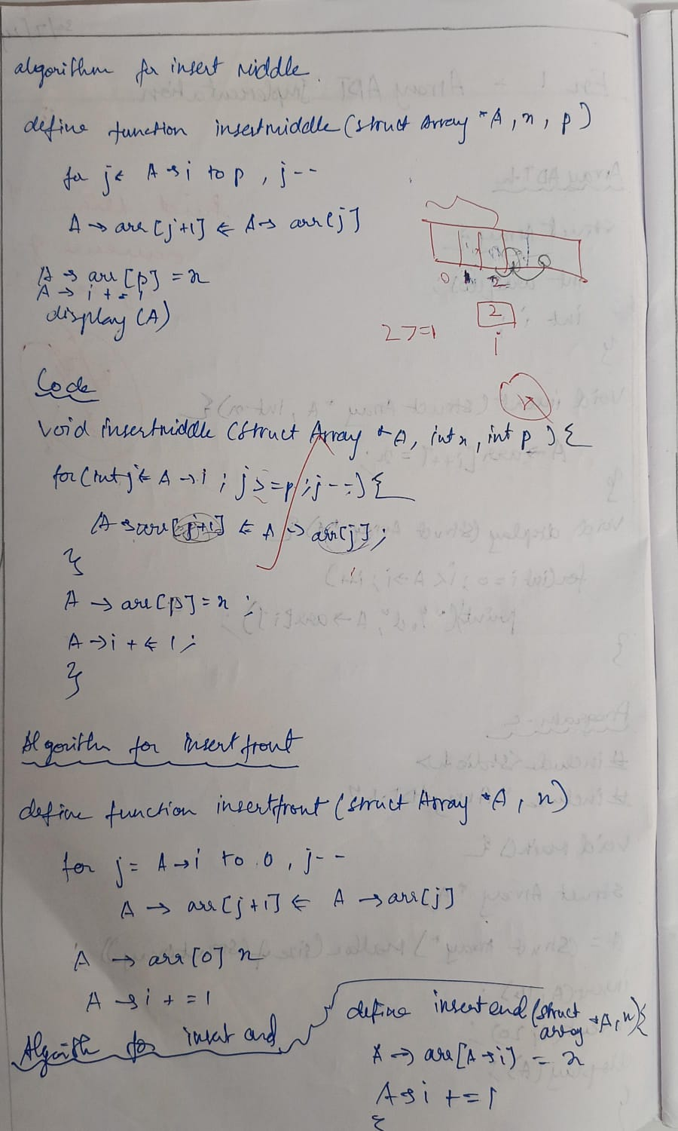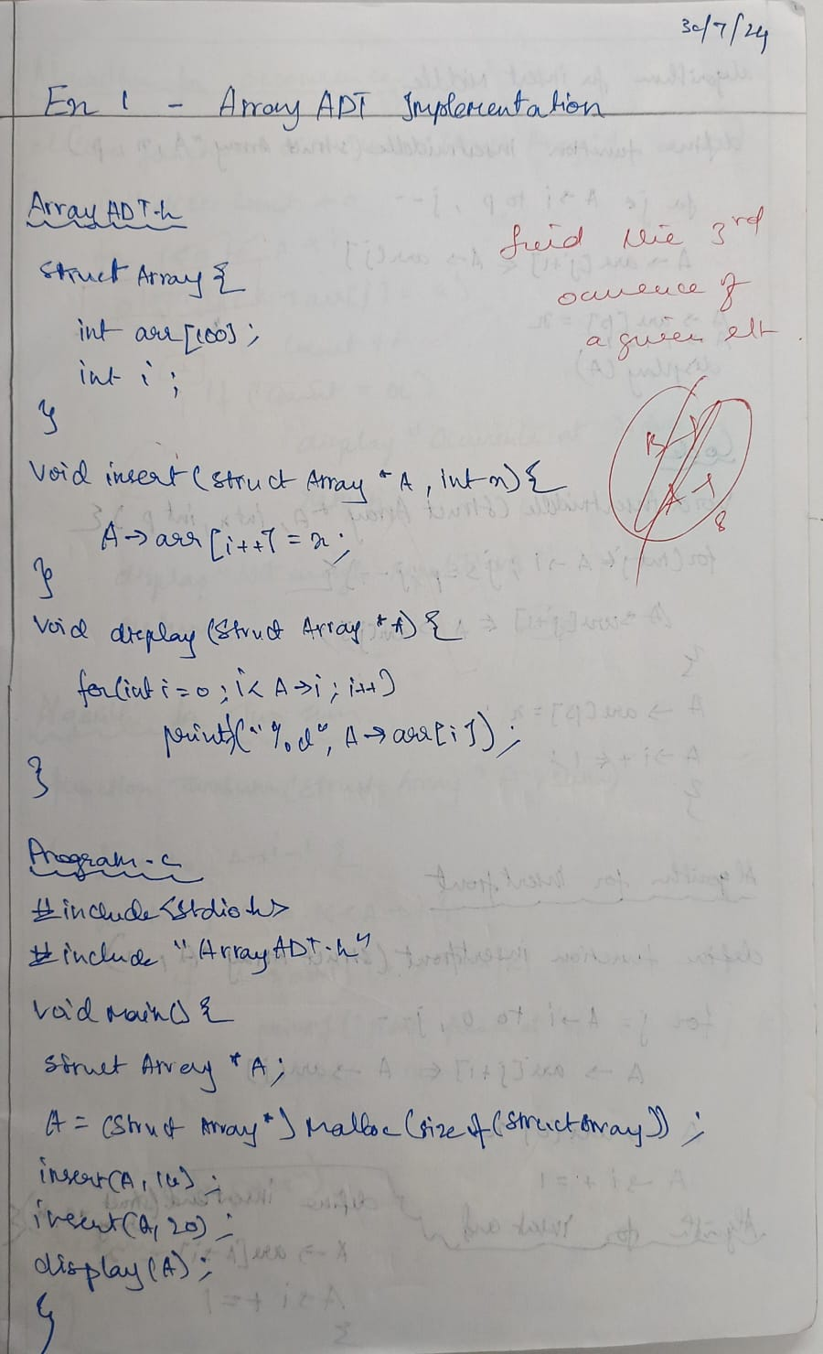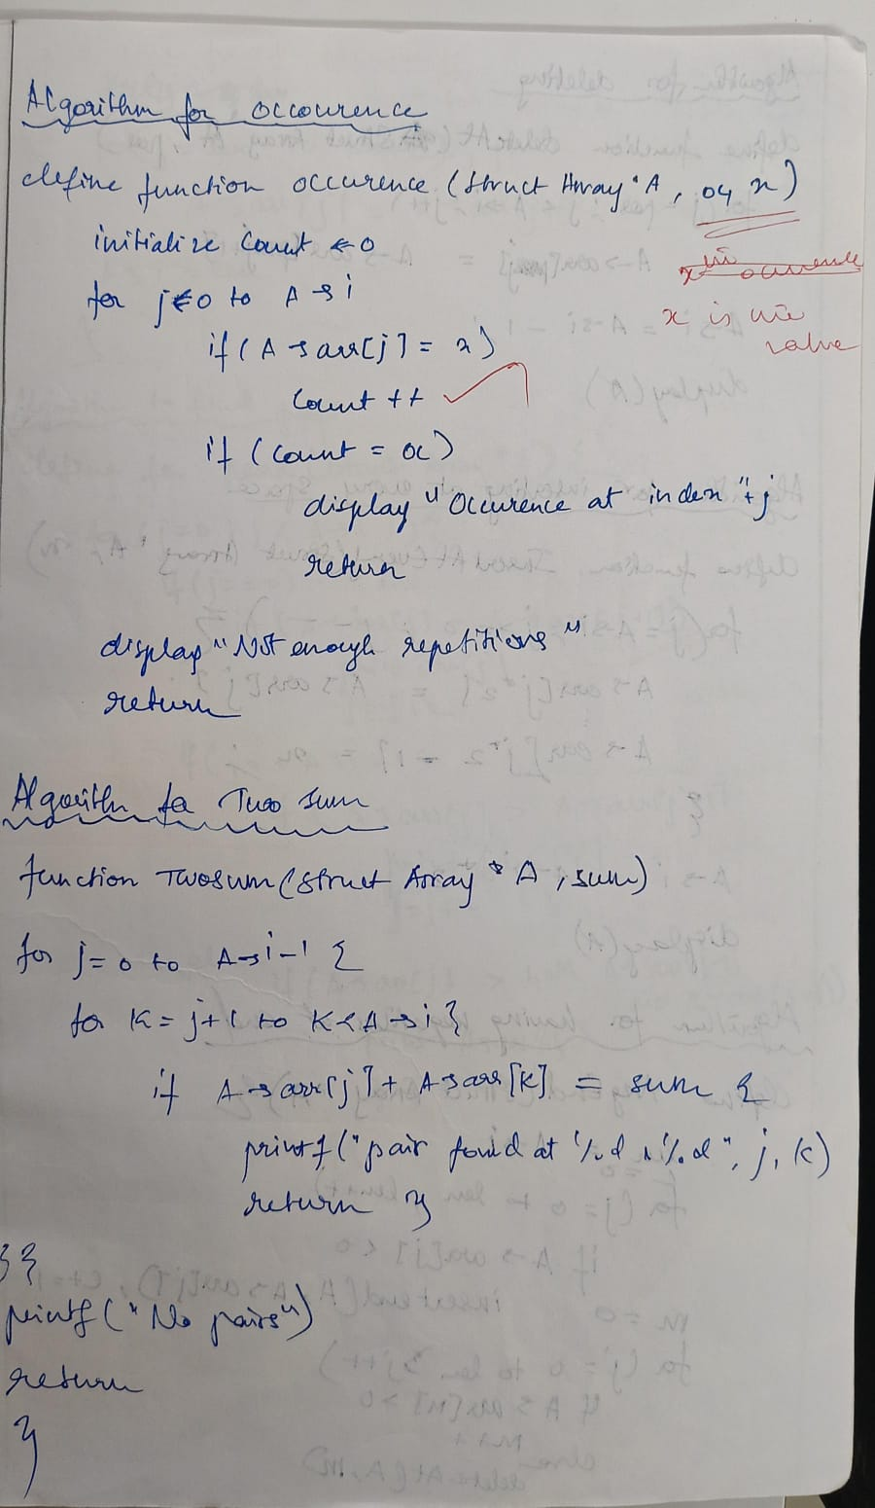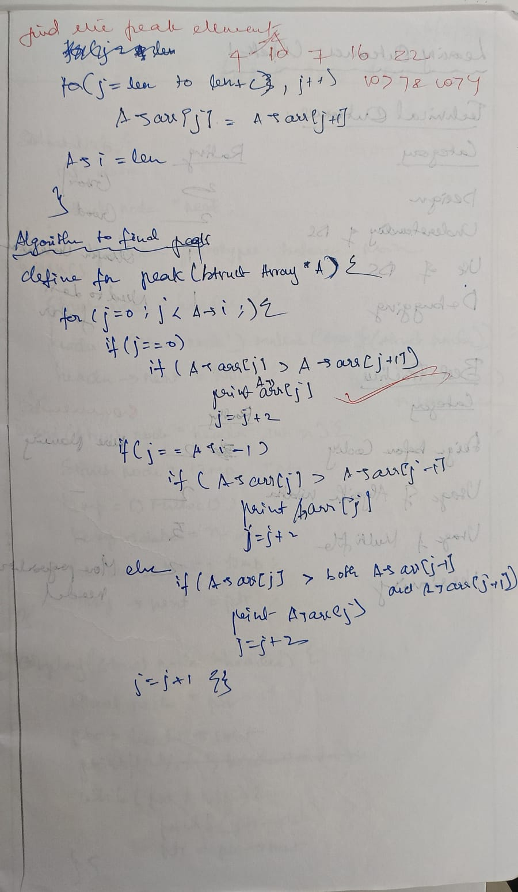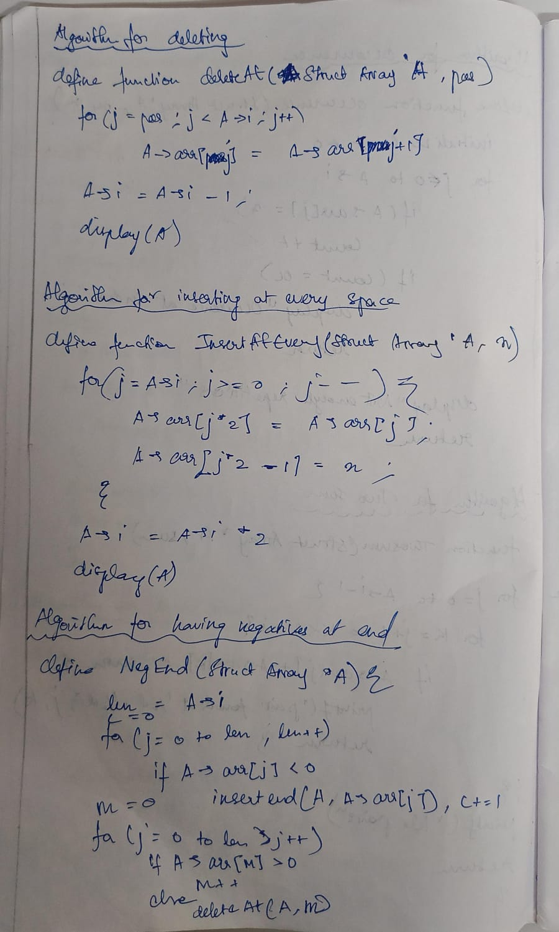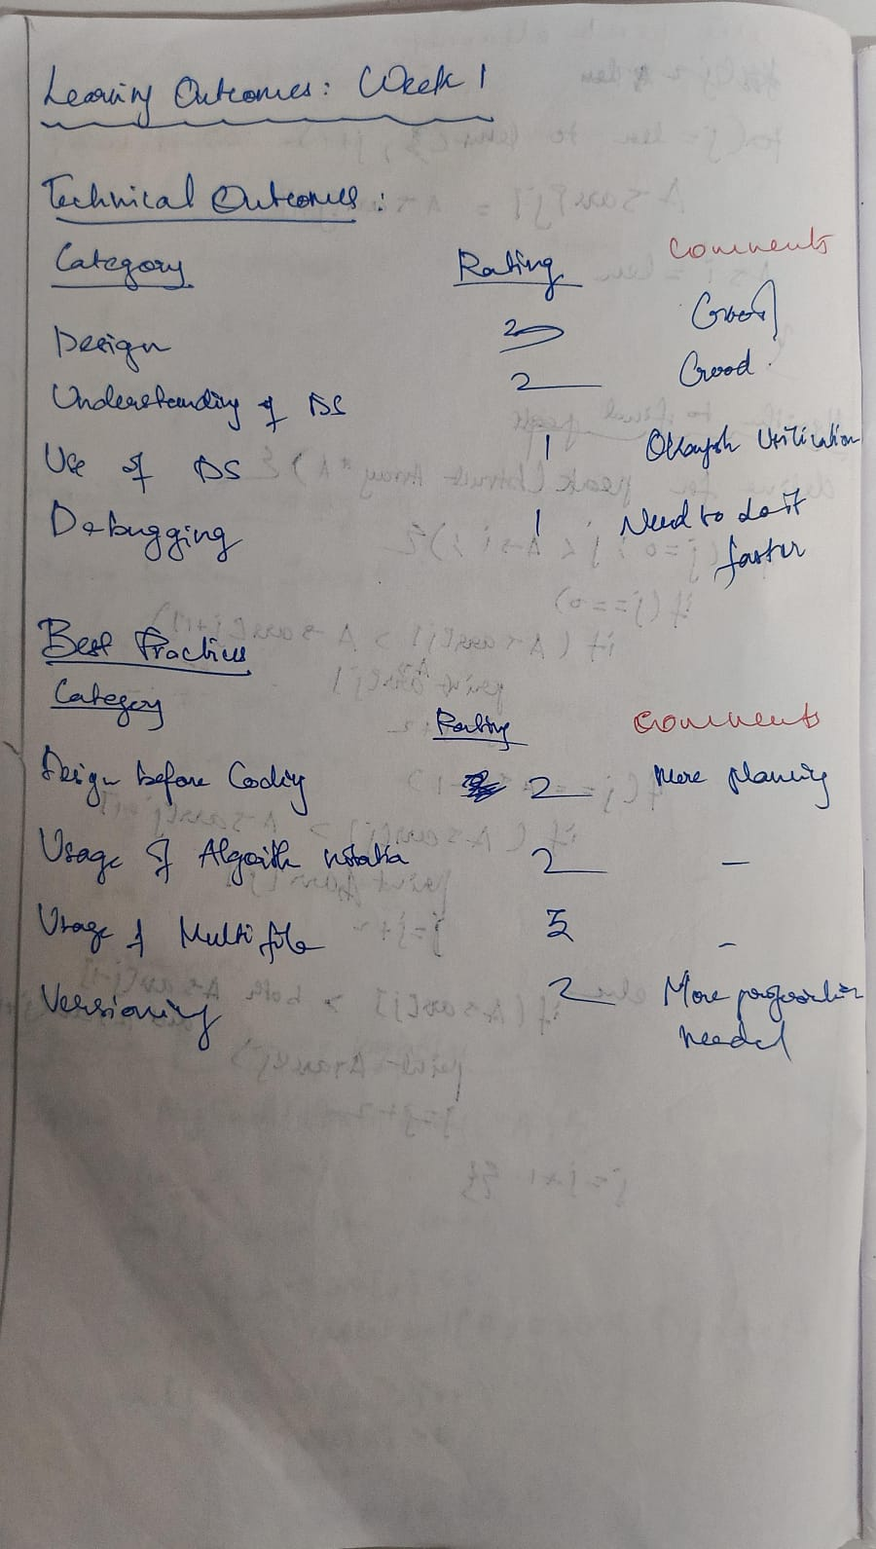

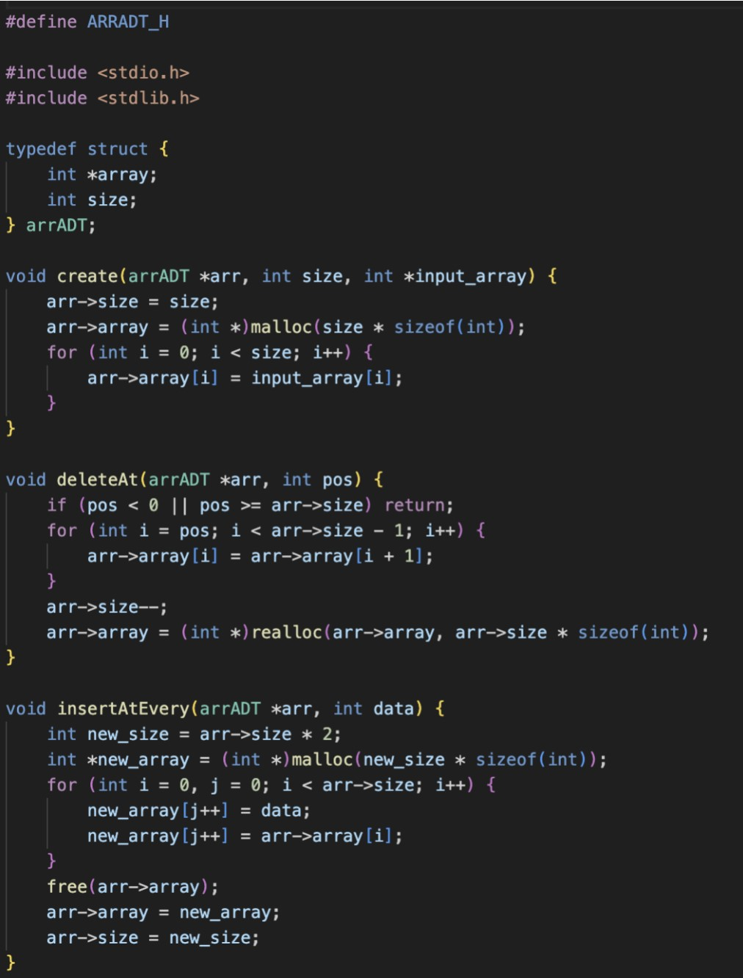

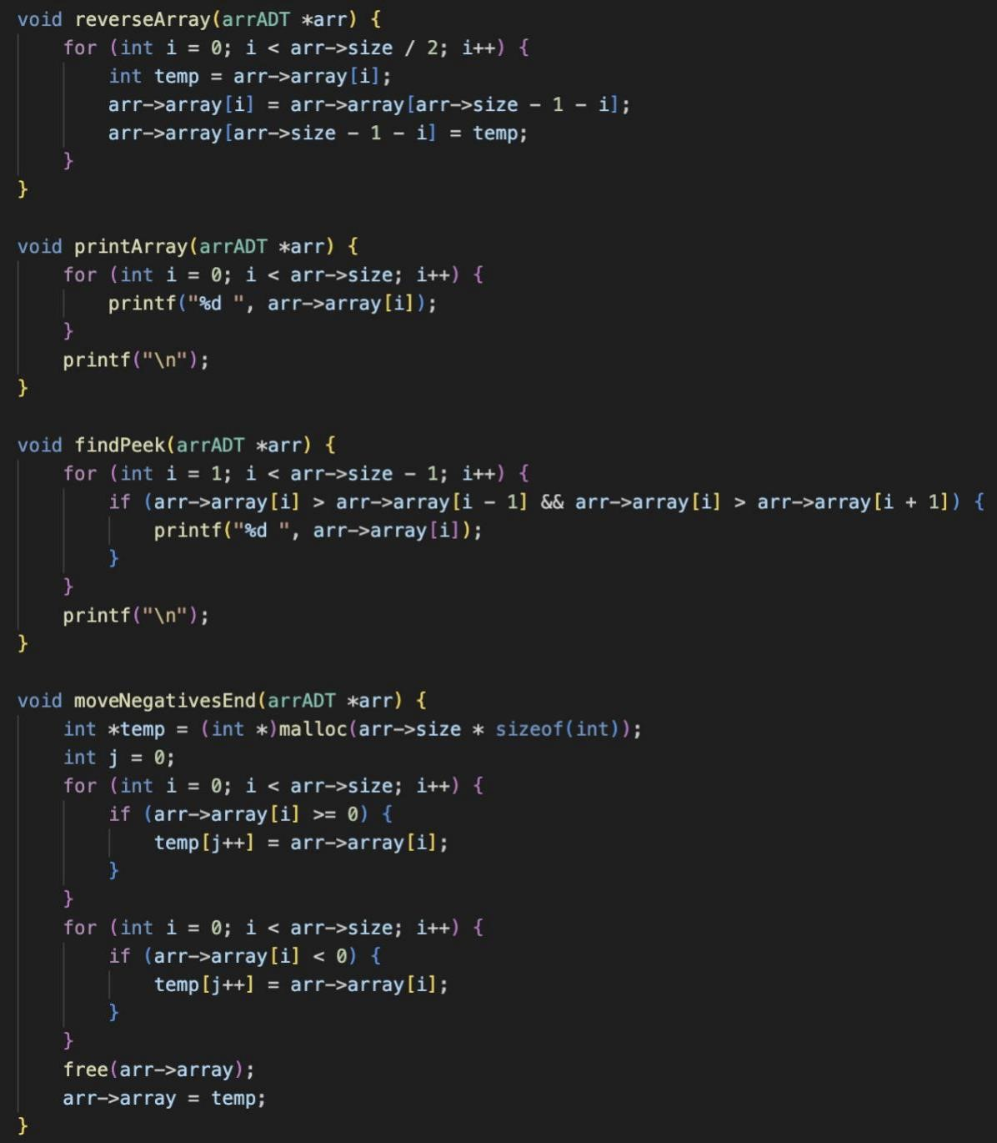

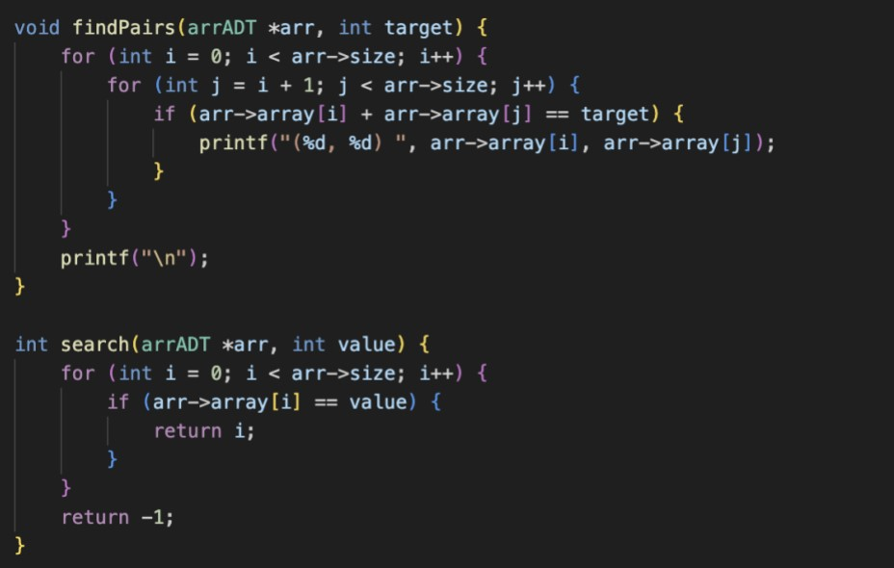

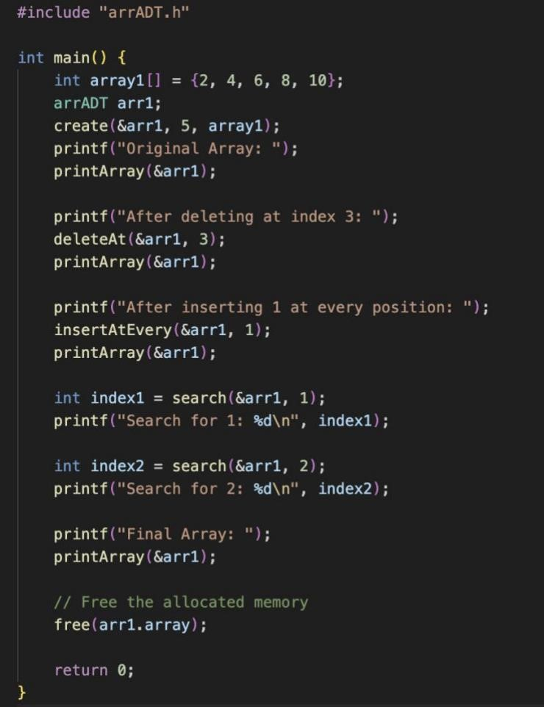

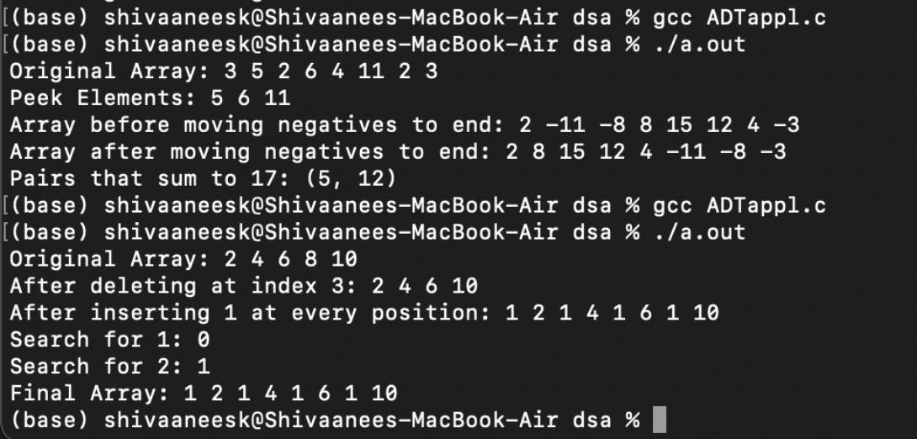

Technical Outcomes

|  |  |  |
| --- | --- | --- |
| Design | 2 | good |
| Understanding of DS | 3 | good |
| Use of DS | 2 | bad |
| Debugging | 1 | Extremely bad |

Best Practices

|  |  |  |
| --- | --- | --- |
| Design before coding | 2 | Needs improvement |
| Usage of Algo | 3 | Very good |
| Multifile | 3 | Very good |
| Versioning | 0 |  |

**UCS 2312 Data Structures Lab**

**Assignment 2: ListADT and its application**

Create an ADT for the linked list data structure with the following functions. list*ADT* will have the

integer array and size. [CO1, K3]

1. insert(header,data) – Insert data into the list using inserting at front
2. display(header) – Display the elements of the list
3. insertAtEnd(header,data) – Insert data at the end of the list
4. searchElt(header, key) – return the value if found, otherwise return -1
5. deleteElt(header,data) – Deletes the element data
6. findMiddleElt(header) – find the middle element in the list
7. reverseList(header) – Reverse the list
8. length(header) – find the length of the list

Write an application to use the listADT to do the following:

Test the operations of listADT with the following test cases

|  |  |
| --- | --- |
| **Operation** | **Expected Output** |
| length(header) | 0 |
| insert(header,2) | 2 |
| insert(header,4) | 4, 2 |
| insert(header,6) | 6, 4, 2 |
| insert(header,8) | 8, 6, 4, 2 |
| length(header) | 4 |
| insertLast(header,1) | 8, 6, 4, 2, 1 |
| insertLast(header,3) | 8, 6, 4, 2, 1, 3 |
| length(header) | 6 |
| findMiddleElt(header) | 2 or 4 |
| reverseList(header) | 3, 1, 2, 4, 6, 8 |
| searchElt(4) | 4 |
| searchElt(5) | -1 |
| deleteElt(2) | 8, 6, 4, 1, 3 |

Best practices to be followed:

* Design before coding
* Usage of algorithm notation
* Use of multi-file C program
* Versioning of code

Write a program to add the given two polynomials Example:

Poly1: 6x7+8x3 +7x2+9,

Poly2: 7x3+6

Resultant Poly: 6x7+15x3+7x2+15

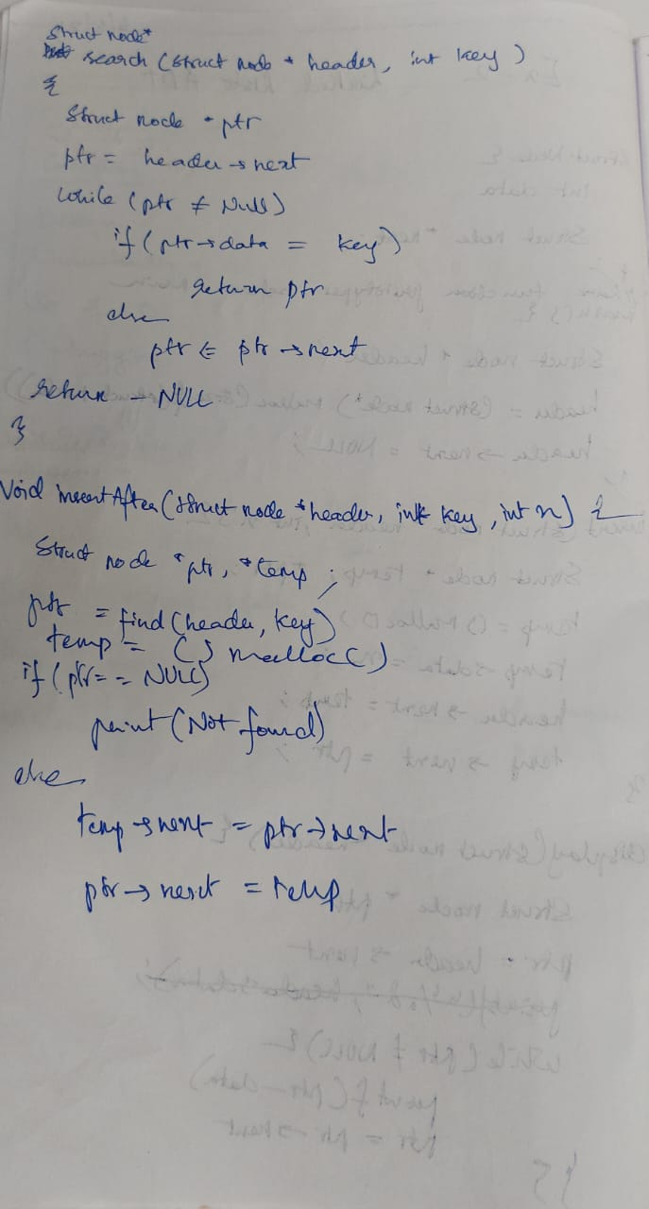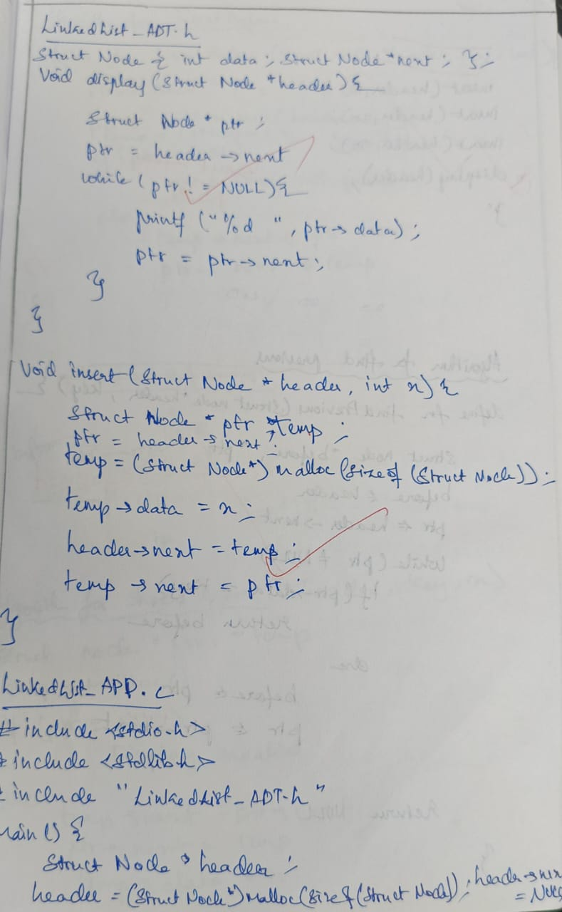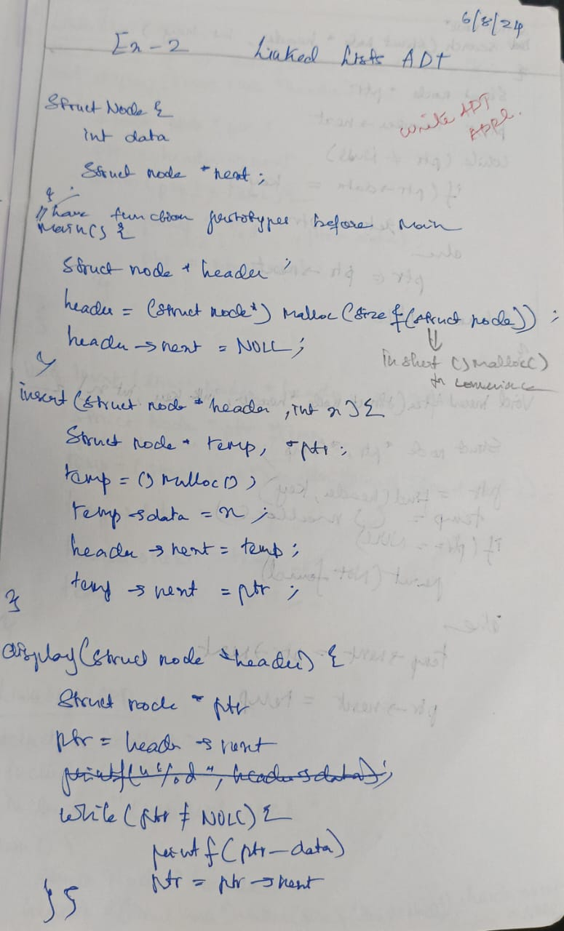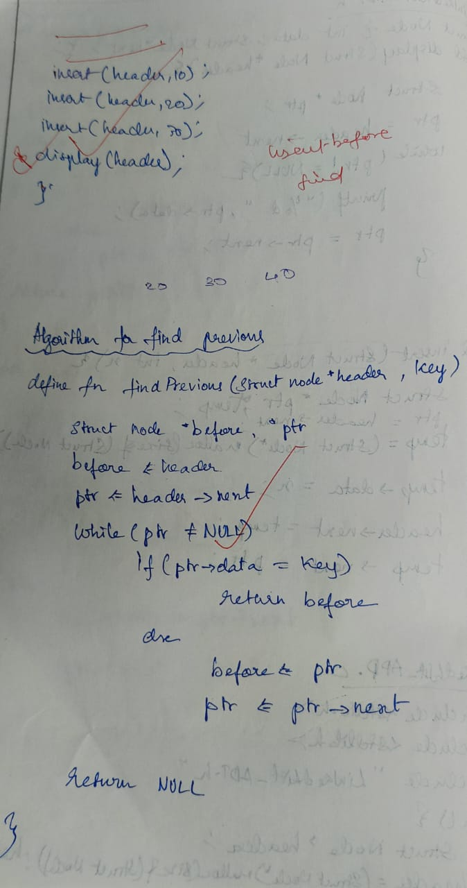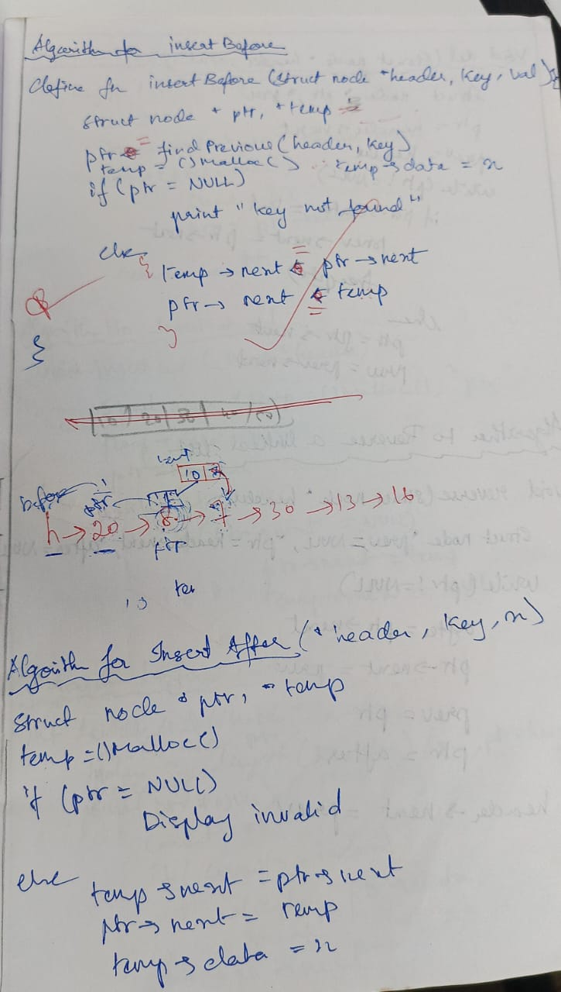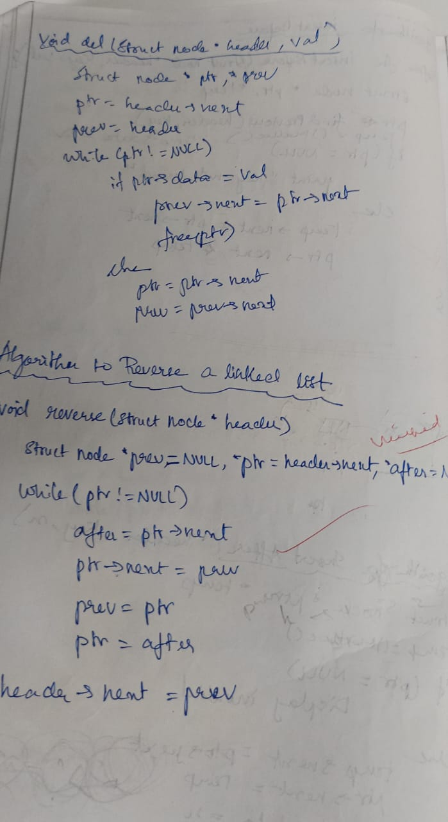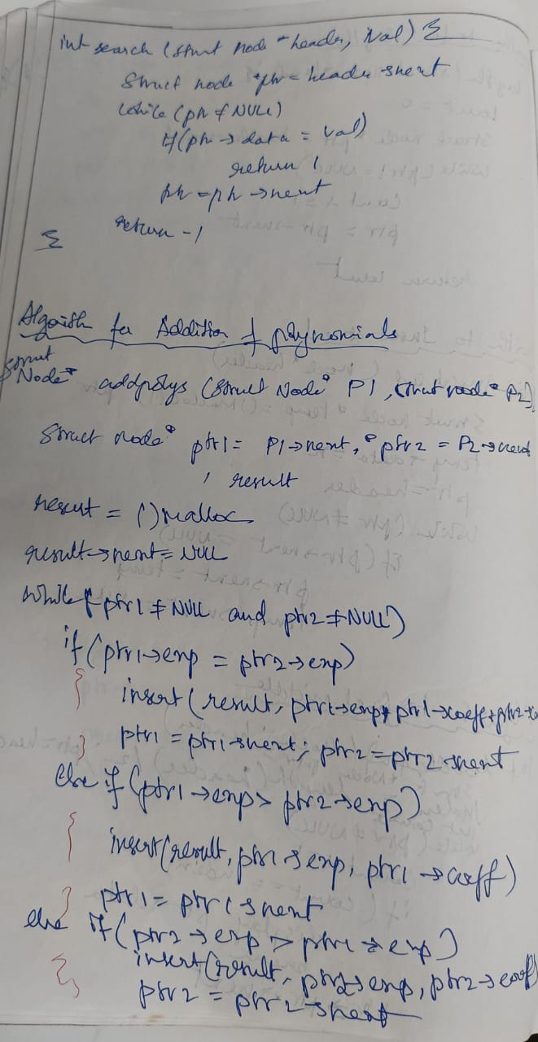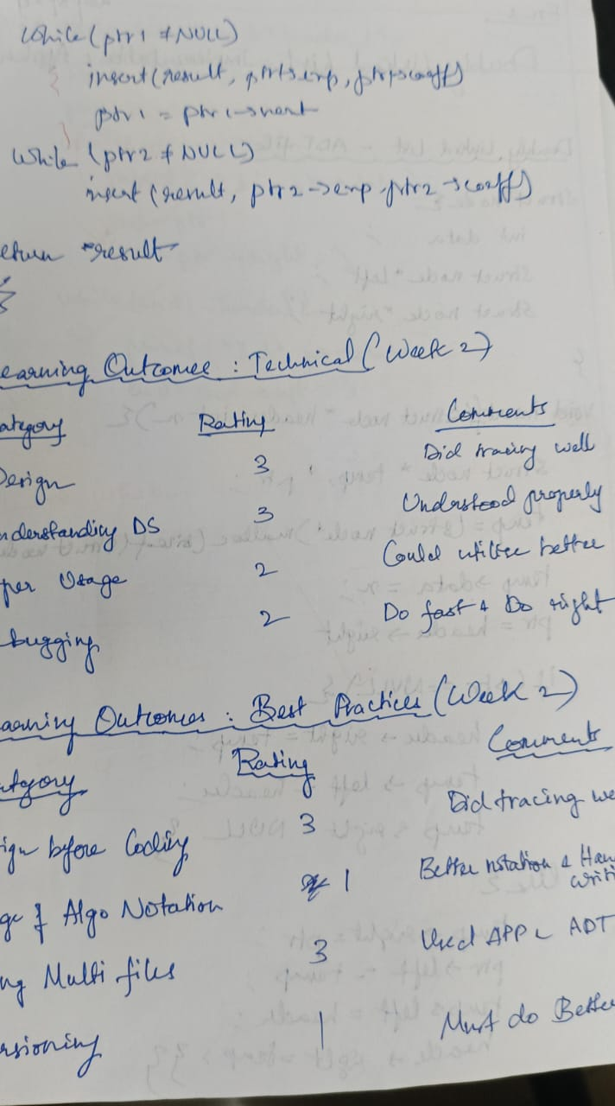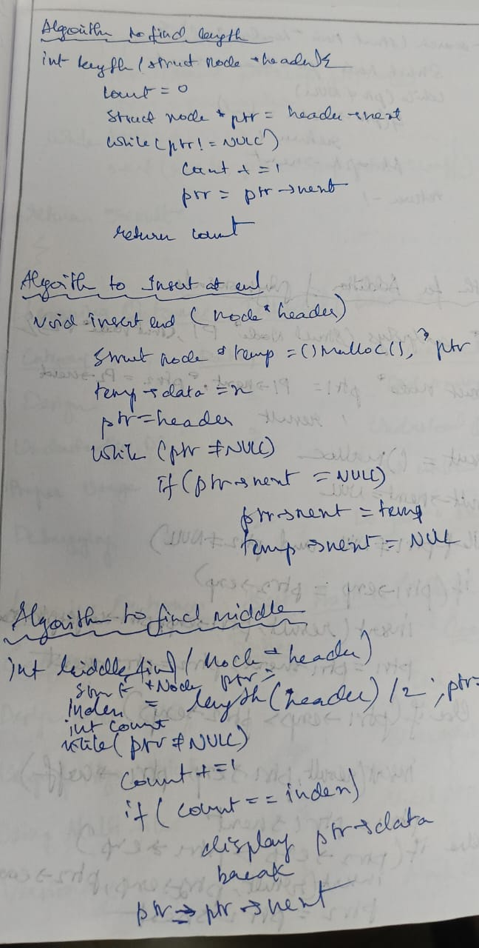

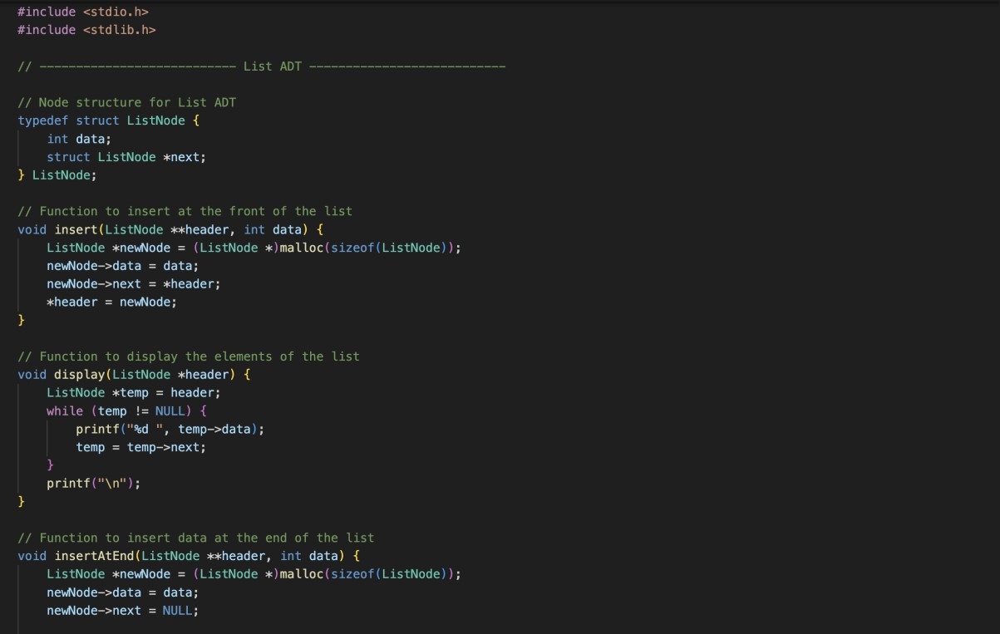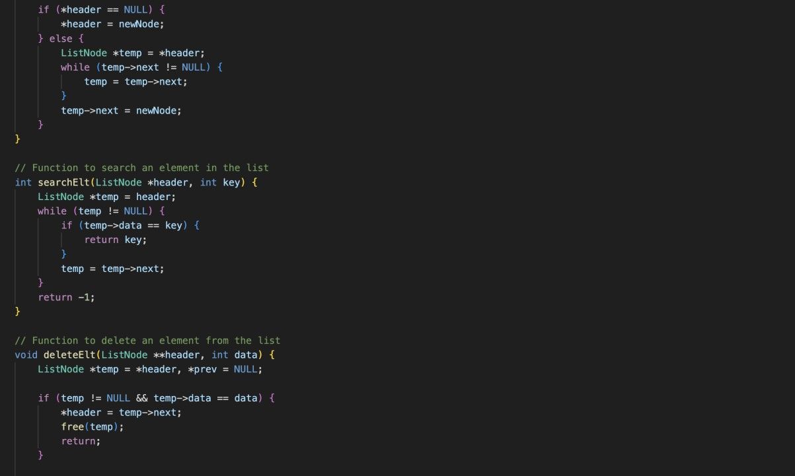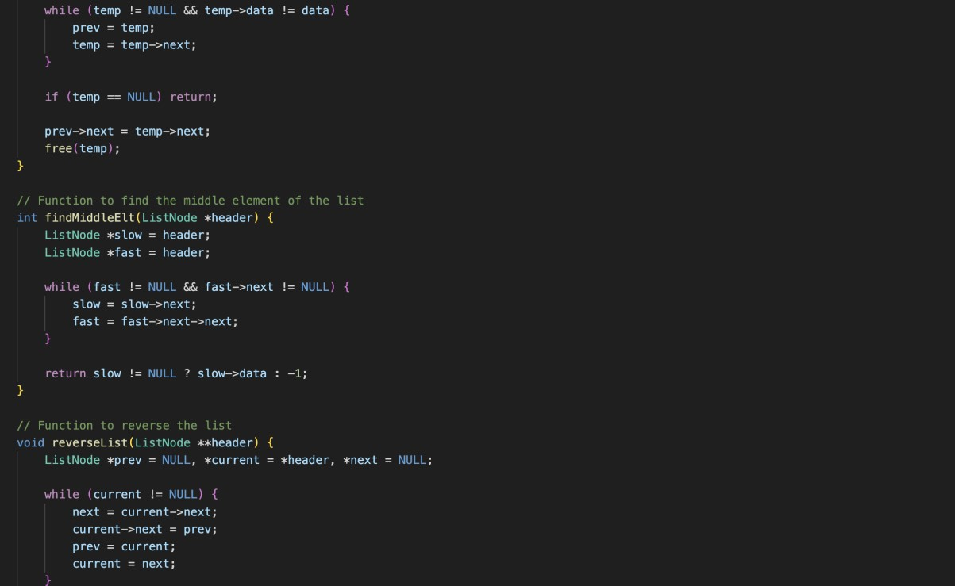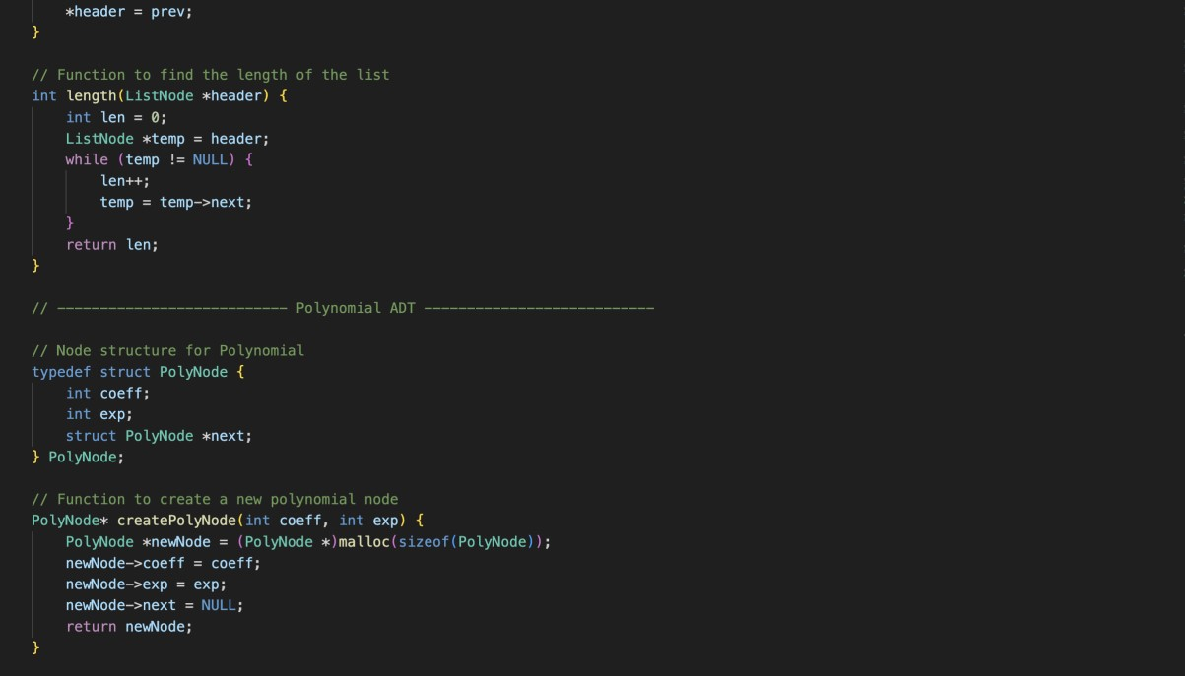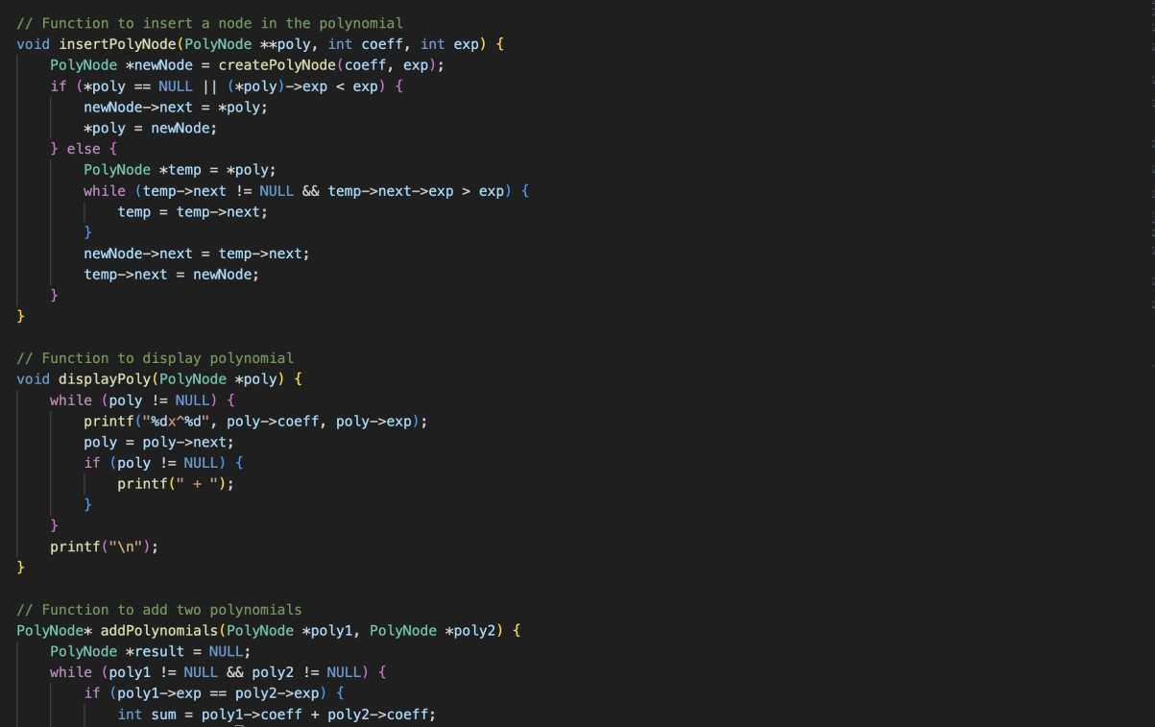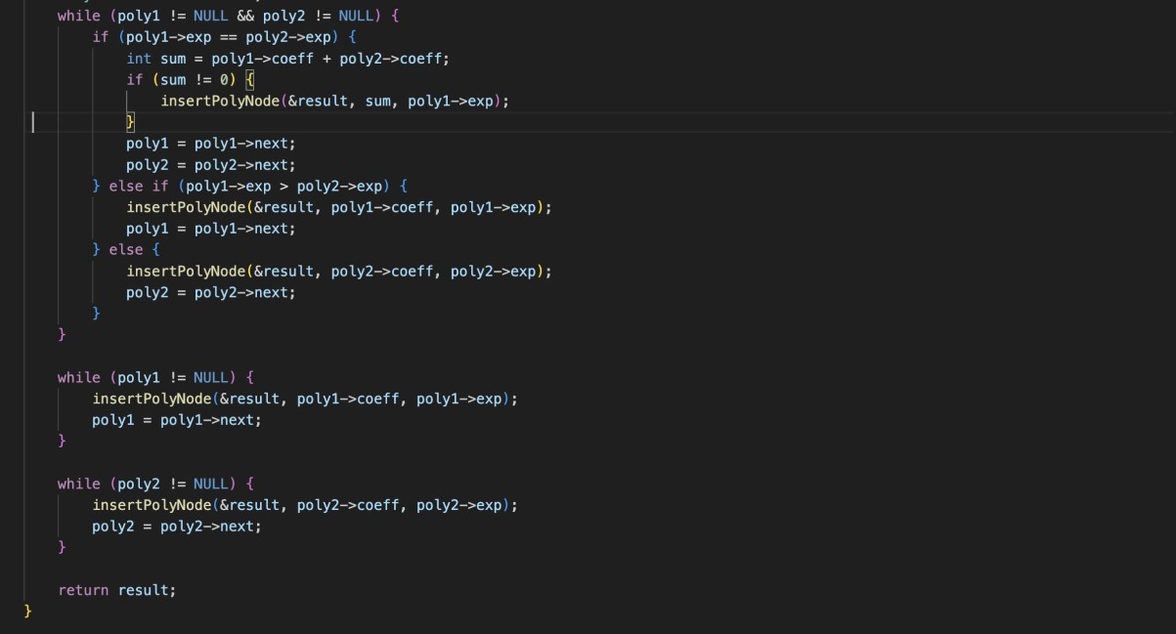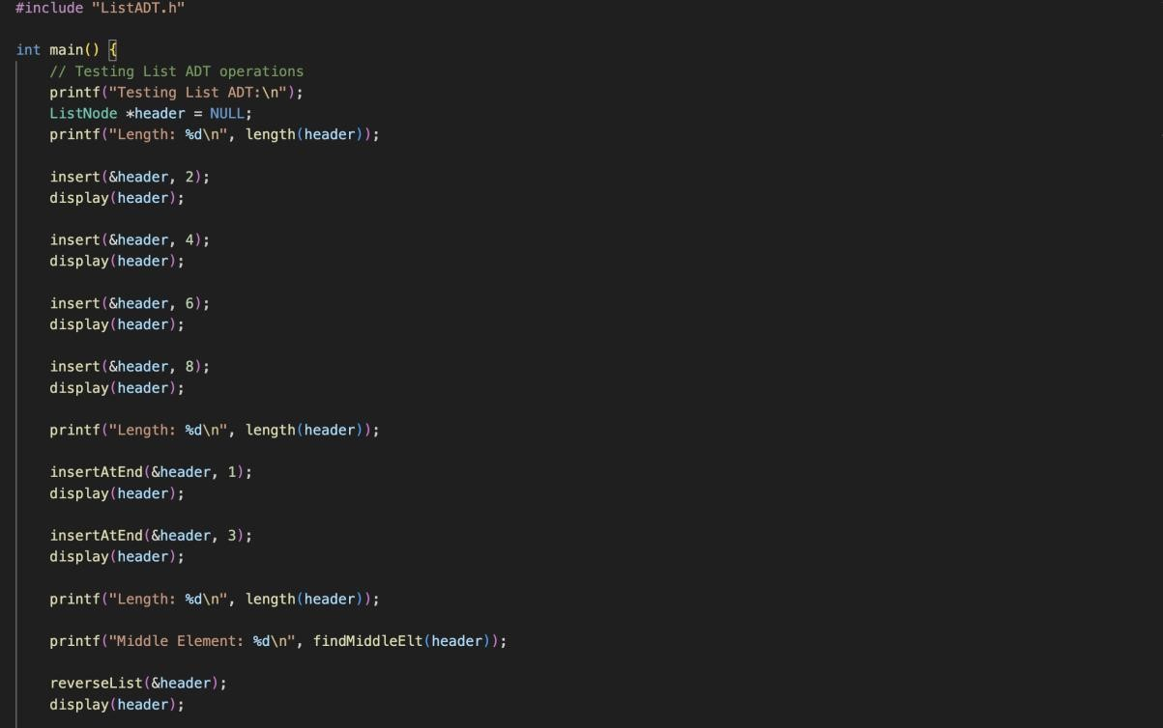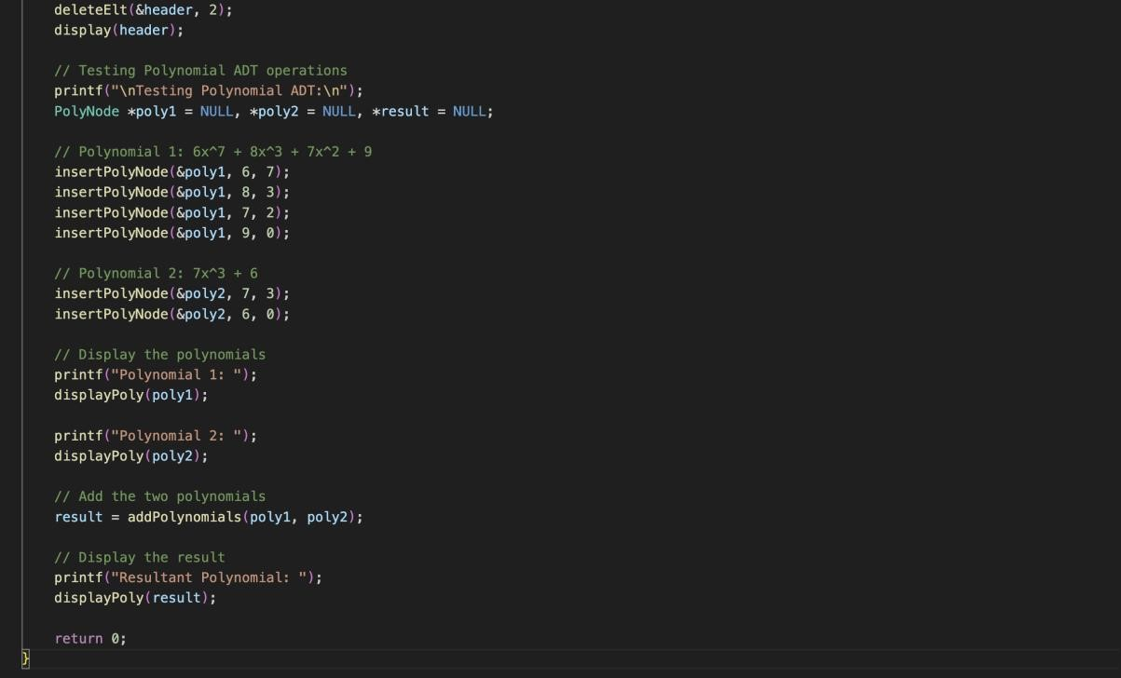

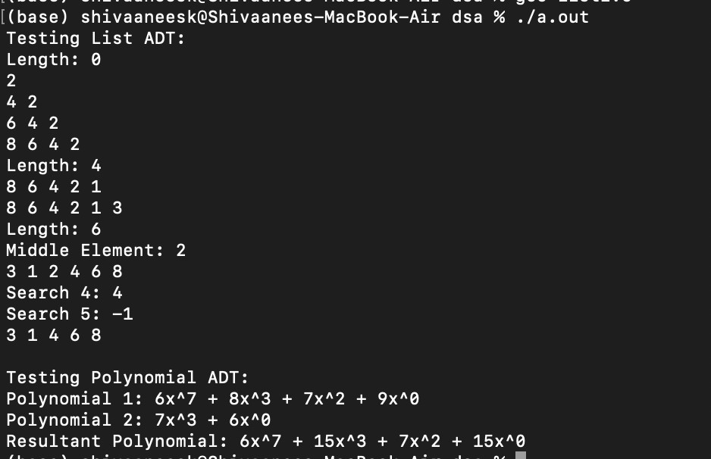

Technical Outcomes

|  |  |  |
| --- | --- | --- |
| Design | 3 | nice |
| Understanding of DS | 3 | Understood prprly |
| Use of DS | 2 | Could do better |
| Debugging | 1 | Was hard |

Best Practices

|  |  |  |
| --- | --- | --- |
| Design before coding | 3 | nice |
| Usage of Algo | 1 | Better notation |
| Multifile | 3 | did |
| Versioning | 1 | didnt |

**UCS 2312 Data Structures Lab**

**Exercise 3: Doubly Linked List and its applications**

Create an ADT for the doubly linked list data structure with the following functions. Each node which consists of integer data, address of left and right nodes [CO1, K3]

Create a ListADT which has implementations for the following operations

1. Insert an item in the front of the list void insertFront(listADT L, int c)
2. Display the items from the list void displayItems(listADT L)
3. Delete the item present in the list void deleteItem(listADT L, int c)
4. Search an element in the list and return the number of occurrences int searchItem(listADT L, int c)

Write a program in C to test the ListADT for its operations with the following test cases.

Testcase:

Initially L is Empty insertFront(L,6) → header←→6

insertEnd(L,2) → header←→2←→6 insertMiddle(L,2,1) → header←→2←→1←→6

insertMiddle(L,2,1) → header←→2←→1←→1←→6 search(L,1) → 2

In addition, do the following operations:

1. Delete the nodes with odd numbers in the list.
2. Replace the nodes with odd sum digit values with random odd numbers
3. Add a single digit to a DLL.

Example: Input:

header←→1←→9←→9←→9

digit =6

Output: header←→2←→0←→0←→5

Input:

header←→1←→9←→9←→3

digit =6

Output: header←→1←→9←→9←→9

Input:

header←→9←→9←→9←→9

digit =6

Output:

header←→1←→0←→0←→0←→5

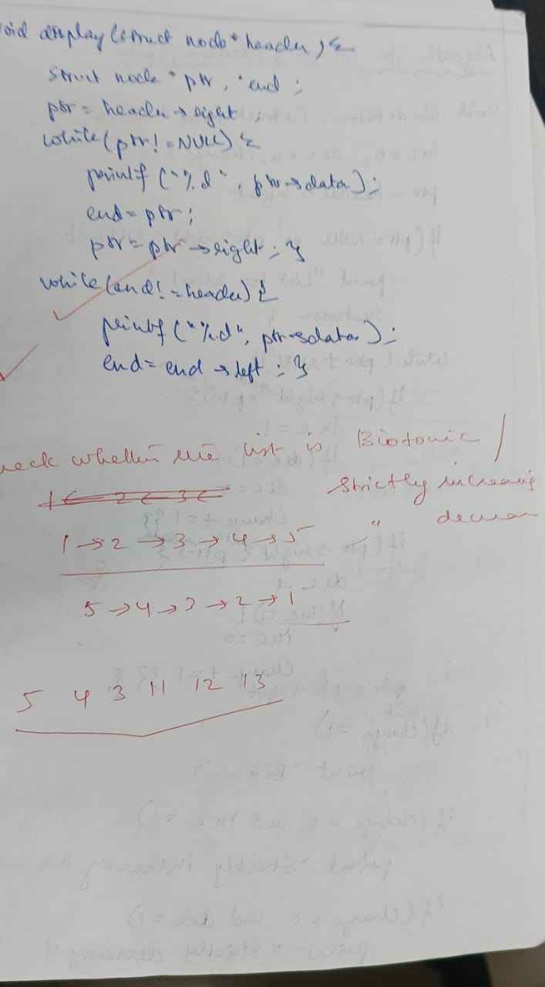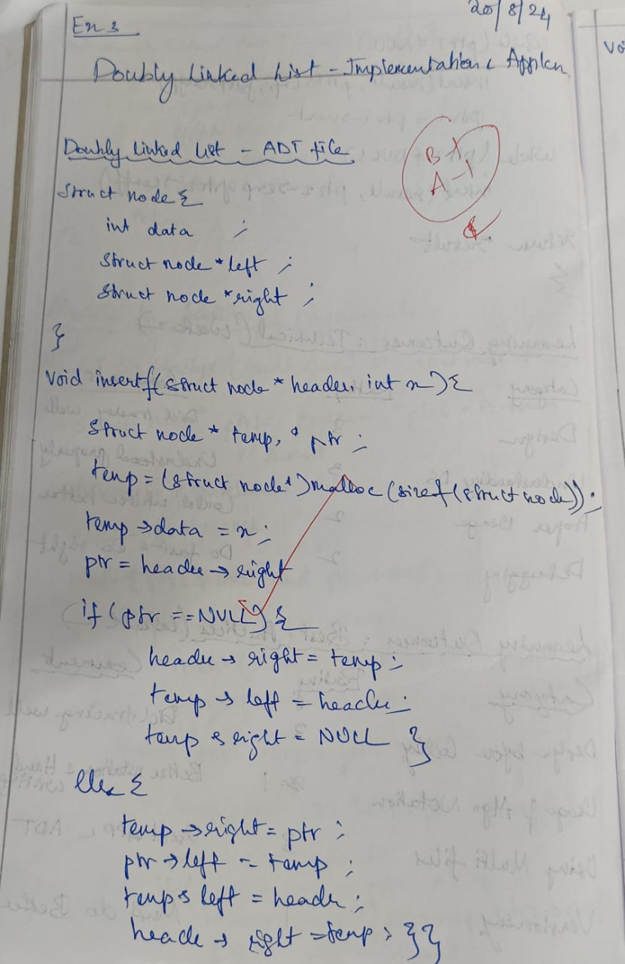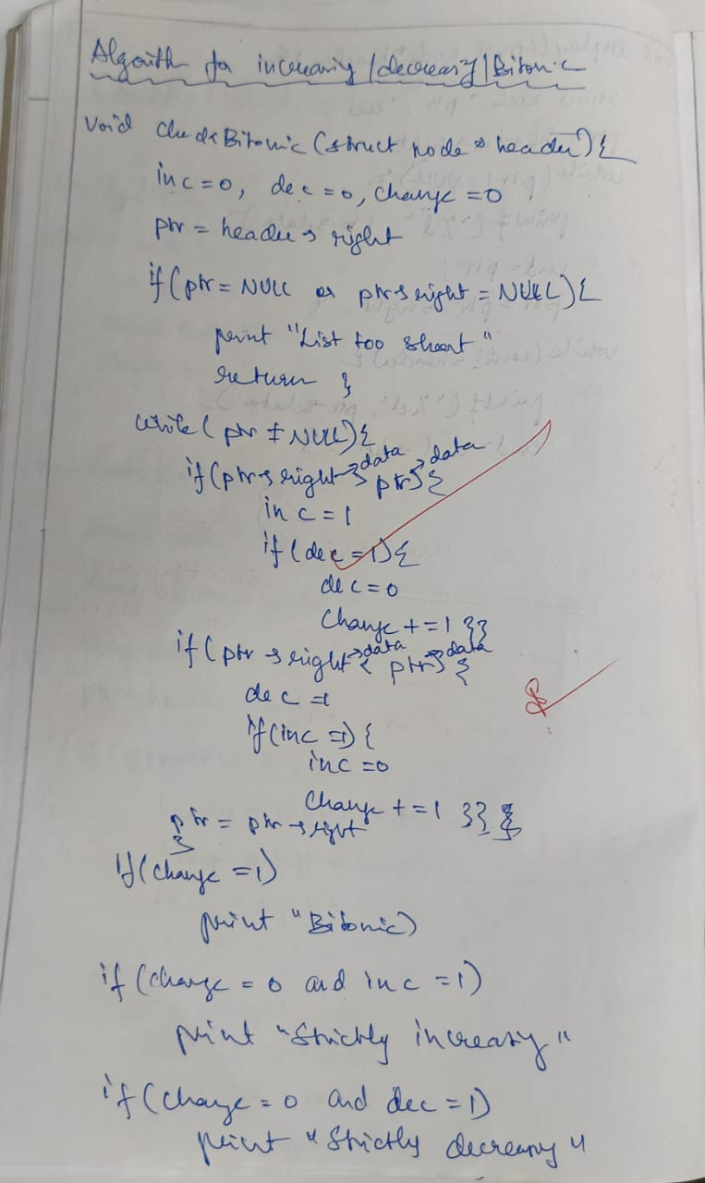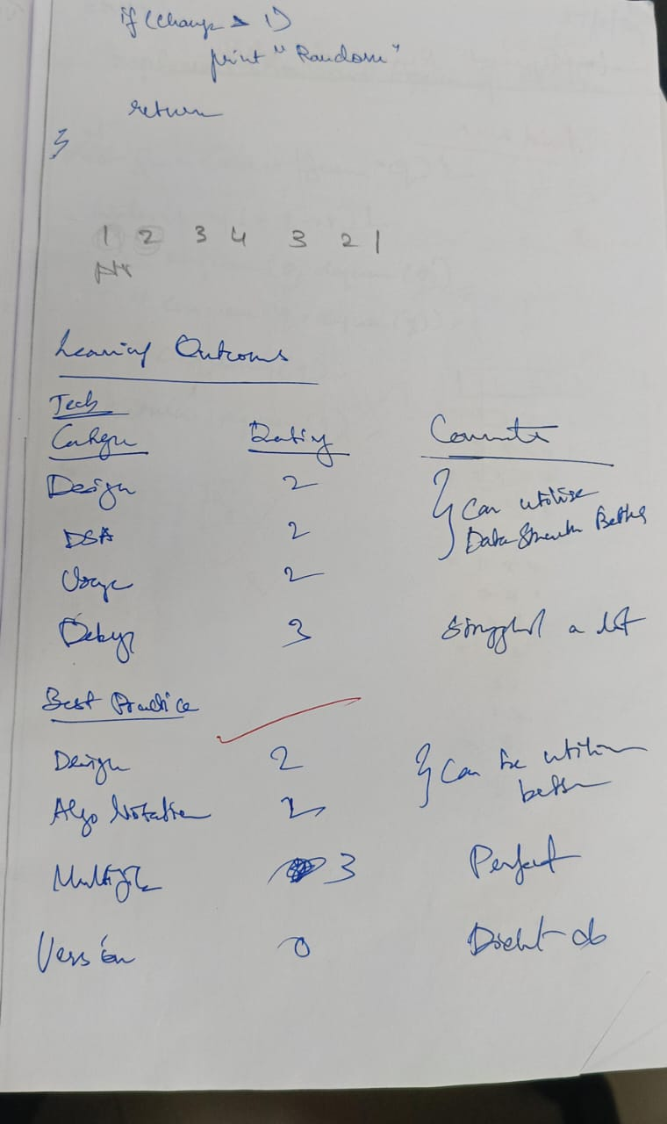

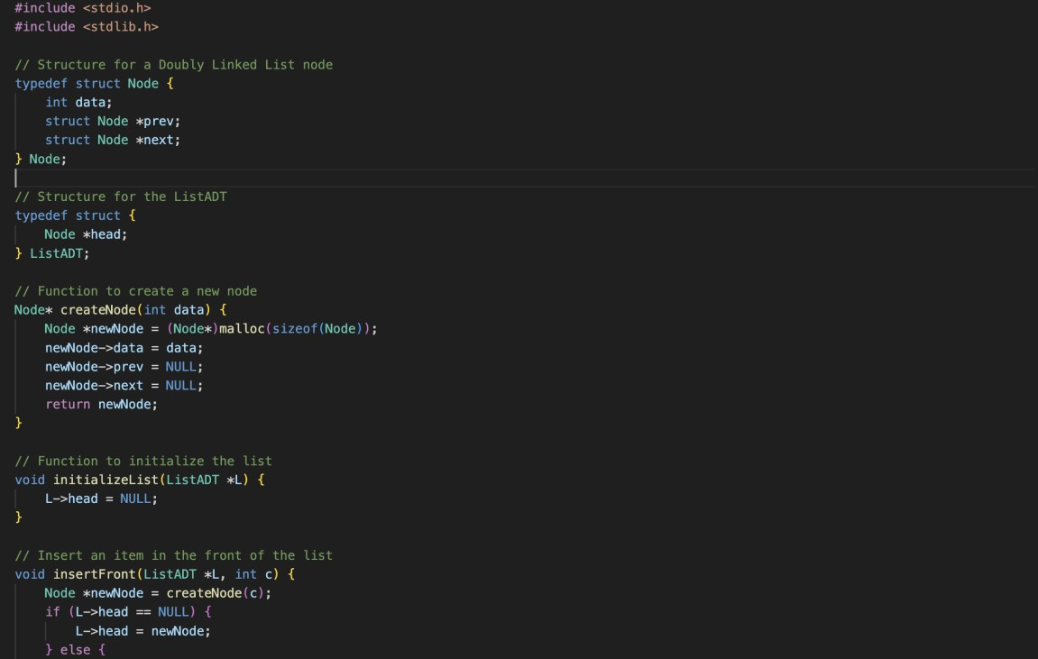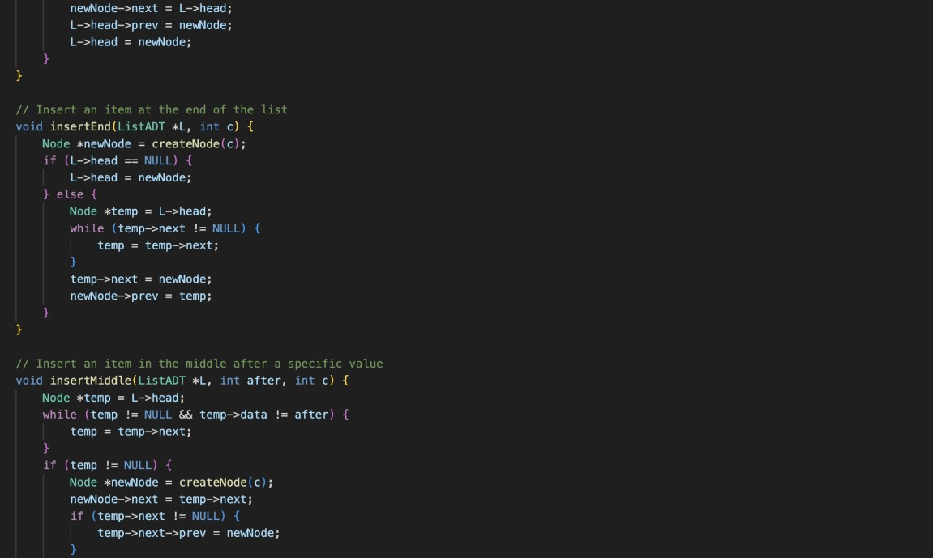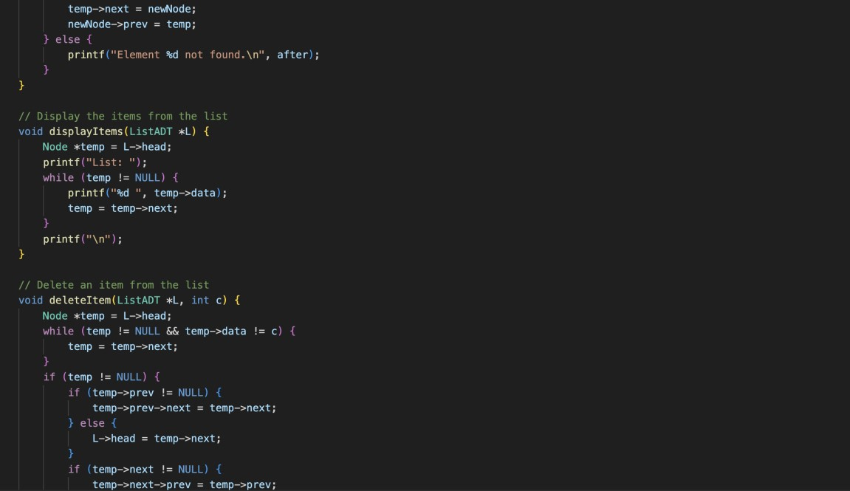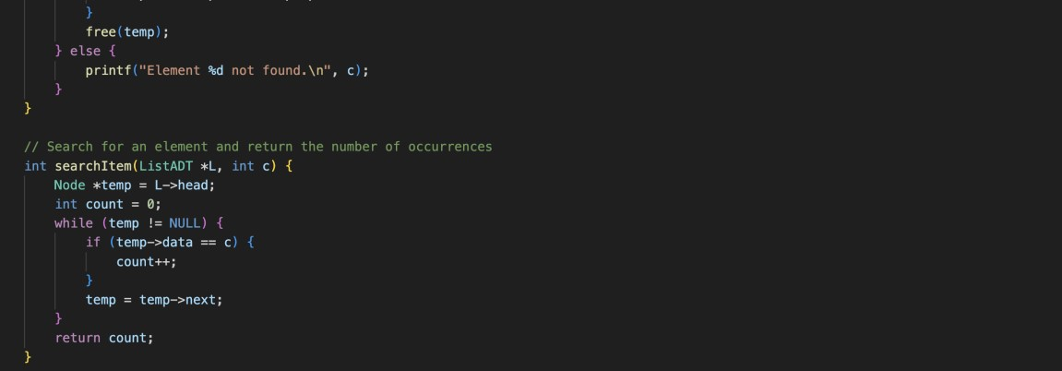

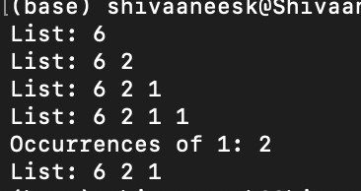

Technical Outcomes

|  |  |  |
| --- | --- | --- |
| Design | 2 | Needs improvement |
| Understanding of DS | 2 | Needs improvement |
| Use of DS | 2 |  |
| Debugging | 3 |  |

Best Practices

|  |  |  |
| --- | --- | --- |
| Design before coding | 2 | Needs improvement |
| Usage of Algo | 2 |  |
| Multifile | 3 |  |
| Versioning | 0 |  |

**UCS 2312 Data Structures Lab**

**Assignment 4: StackADT and its application**

Create an ADT for the stack data structure with the following functions. stack*ADT* will have the

integer array, top and size. [CO1, K3]

1. createStack(top) – initialize size and top with -1
2. push(top,data) – push data into the stack if stack is not full. Print a message when stack

is

full

1. pop(top) – decrements the top by 1
2. peek(top)– returns the element at top, if stack is not empty, otherwise returns -1
3. isEmpty(top) – returns 1 if stack empty, otherwise returns 0
4. isFull(top) – returns 1 if stack full, otherwise returns 0

Test the operations of stackADT with the following test cases

|  |  |
| --- | --- |
| **Operation** | **Expected Output** |
| peek(top) | Empty |
| push(top,2) | 2 |
| push(top,4) | 4, 2 |
| push(top,6) | 6, 4, 2 |
| push(top,8) | Full |
| pop(top) |  |
| peek(top) | 4 |
| peek(top) | 4 |
| pop(top) |  |
| pop(top) |  |
| peek(top) | Empty |
| pop(top) |  |
| pop(top) |  |
| push(top,11) | 11 |
| peek(top) | 11 |

Best practices to be followed:

* Design before coding
* Usage of algorithm notation
* Use of multi-file C program
* Versioning of code

**Application using Stack**

1. Apply the stack to check whether the given input is balanced or not?

Examples:

[[ ), [ ()() ], ( ( [][] ) )

1. Convert the given decimal number into binary using stack Example: 14

Ans: 1110

1. Understand the following procedure to use Stack and trace it for the input: input: [34, 3, 31, 98, 92, 23] and write an algorithm.
   * Create a temporary stack say **tmpStack**.
   * While input stack is NOT empty do this:
     + Pop an element from input stack call it **temp**
     + while temporary stack is NOT empty and top of temporary stack is greater than temp,

pop from temporary stack and push it to the input stack

* + - push **temp** in temporary stack • Print the numbers in tmpStack Predict the output ??? = [ ]

1. Given an array of integers temperatures represents the daily temperatures, return *an array* answer *such that* answer[i] *is the number of days you have to wait after the* ith *day to get a warmer temperature*. If there is no future day for which this is possible, keep answer[i] == 0 instead. (use stack)

**Example 1:**

**Input:** temperatures = [73,74,75,71,69,72,76,73] **Output:** [1,1,4,2,1,1,0,0] **Example 2:**

**Input:** temperatures = [30,40,50,60]

**Output:** [1,1,1,0]

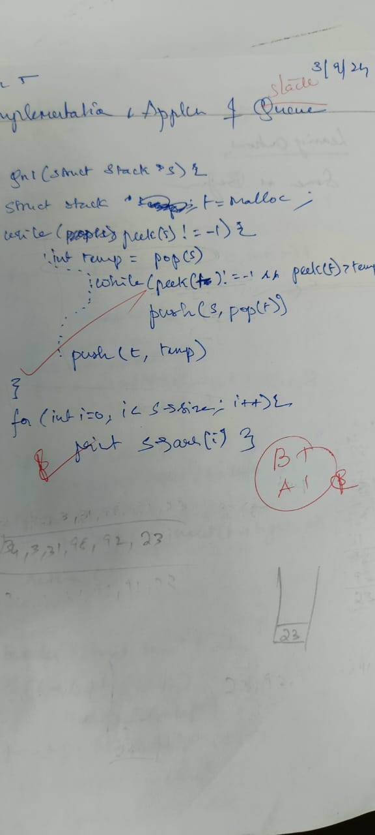

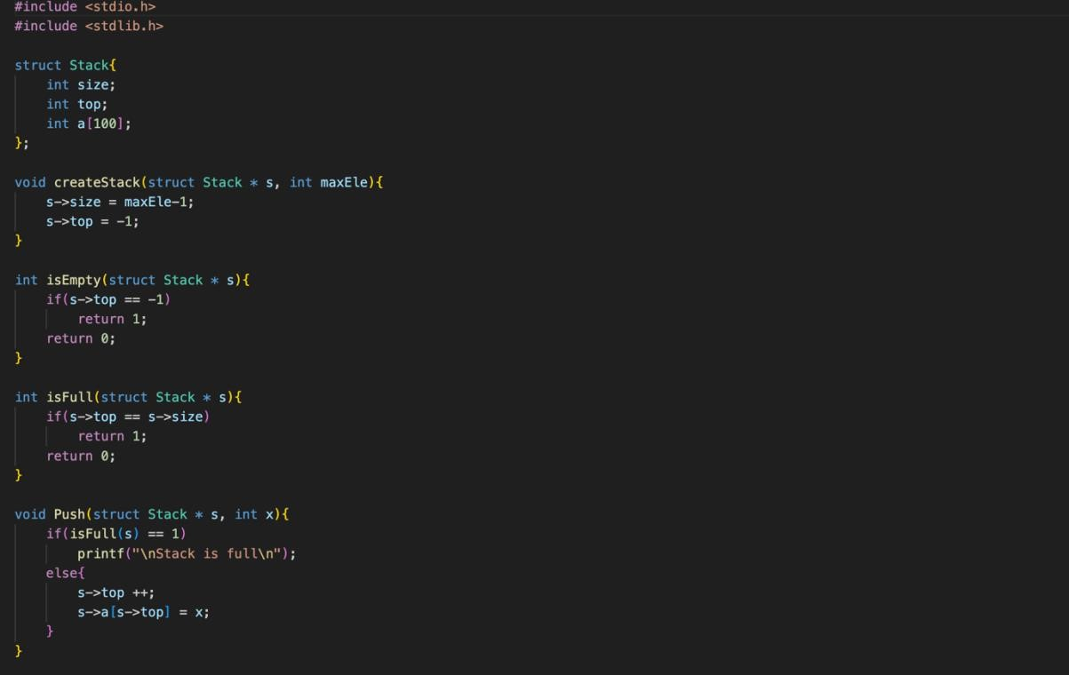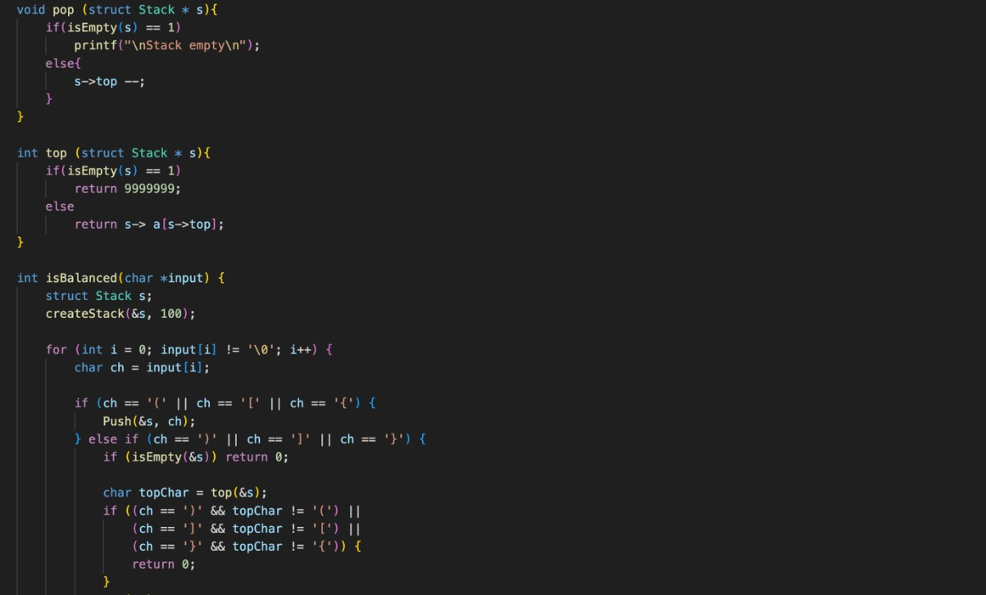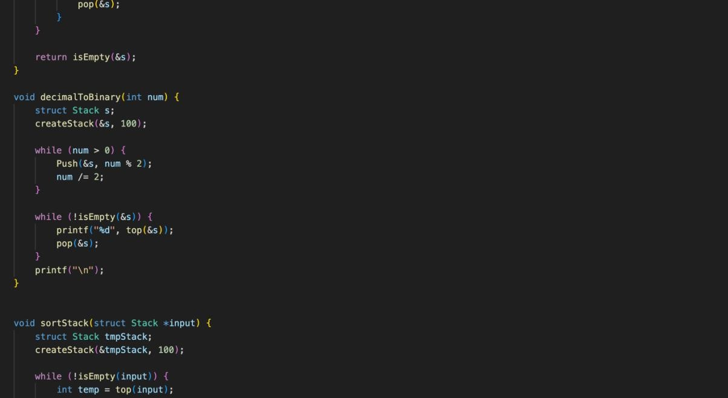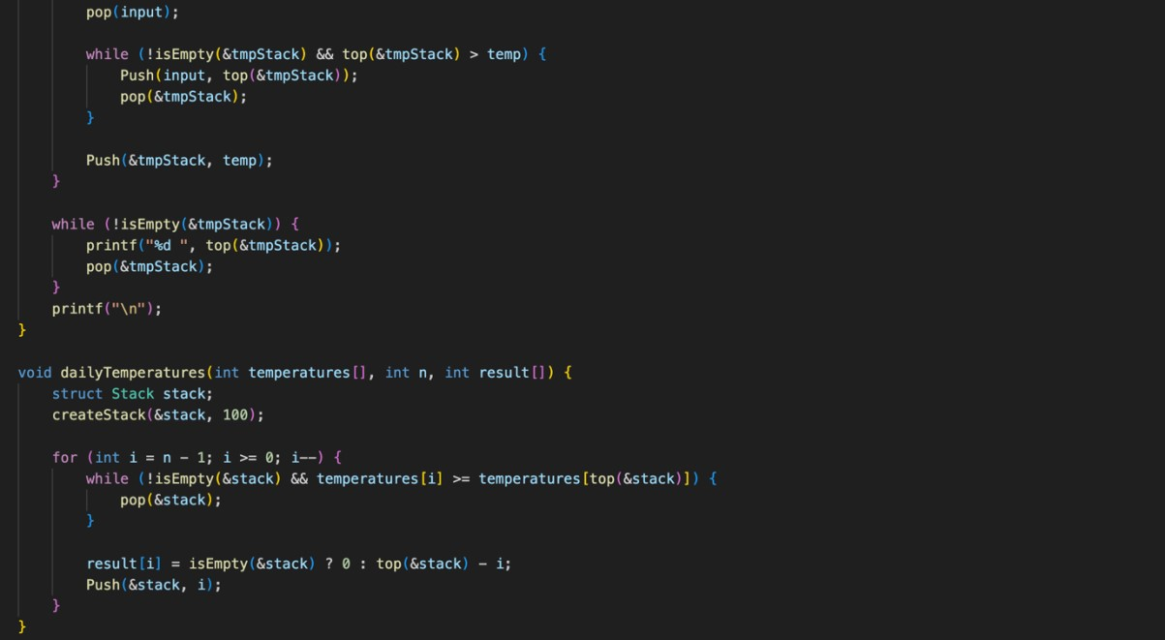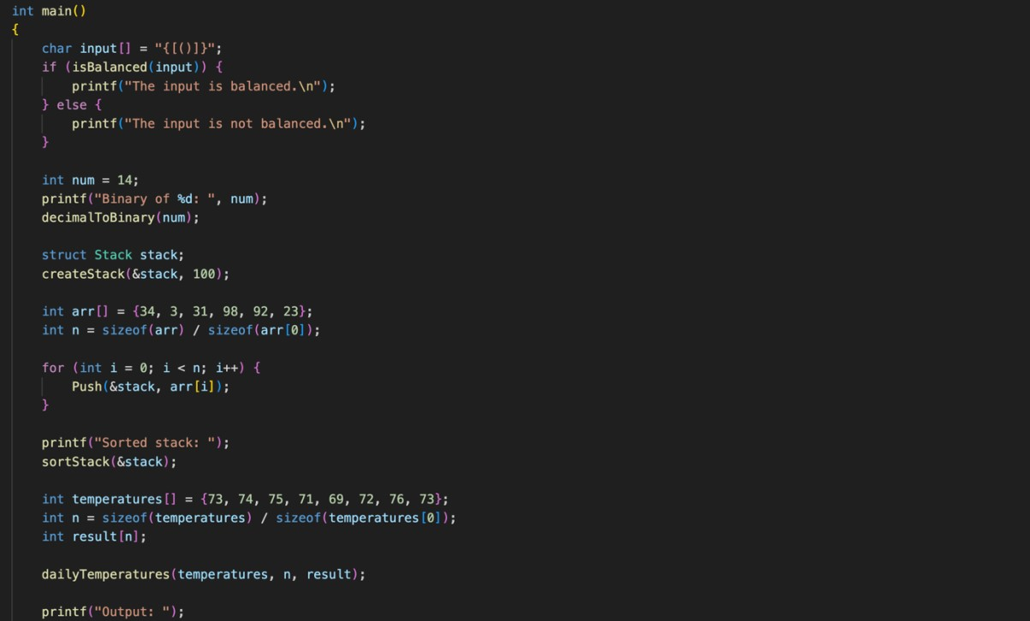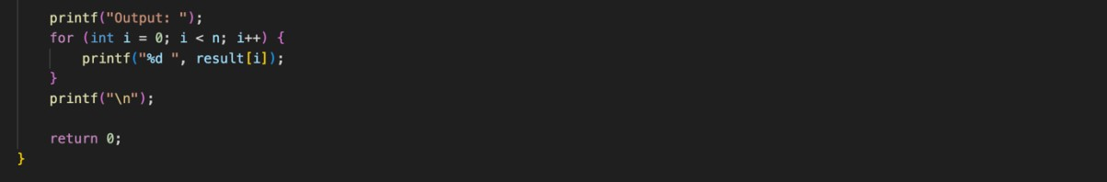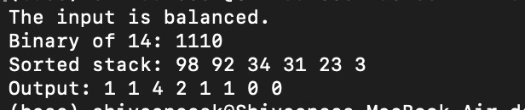

Technical Outcomes

|  |  |  |
| --- | --- | --- |
| Design | 2 | Needs improvement |
| Understanding of DS | 2 | Needs improvement |
| Use of DS | 3 |  |
| Debugging | 3 |  |

Best Practices

|  |  |  |
| --- | --- | --- |
| Design before coding | 2 | Needs improvement |
| Usage of Algo | 3 |  |
| Multifile | 3 |  |
| Versioning | 3 |  |

**UCS 2312 Data Structures Lab**

**Assignment 5: QueueADT and its applications**

Create an ADT for the circular queue data structure with the following functions. queue*ADT* will

have the integer array, front and rear. [CO1, K3]

1. createQueue(Q) – initialize size and front and rear with -1
2. enqueue(Q,data) – push data into the queue if queue is not full.
3. Dequeue(Q) – returns the data if queue is not empty. otherwise, the function returns -1
4. isEmpty(Q) – returns 1 if queue empty, otherwise returns 0
5. isFull(Q) – returns 1 if queue full, otherwise returns 0

Test the operations of queueADT with the following test cases

|  |  |
| --- | --- |
| **Operation** | **Expected Output** |
| createQueue(Q, 2) |  |
| enqueue(Queue,10) | 10 |
| enqueue(Queue,20) | 20 |
| enqueue(Queue,30) | Full |
| dequeue(Queue) | 10 |
| dequeue(Queue) | 20 |
| dequeue(Queue) | Empty |

**Best practices to be followed:**

* Design before coding
* Usage of algorithm notation
* Use of multi-file C program
* Versioning of code

**Application using Queue**

Implement an **integer Circular Queue ADT** and driver to use the queue. Write an algorithm to play **Hot Potato Game** to find the winner.

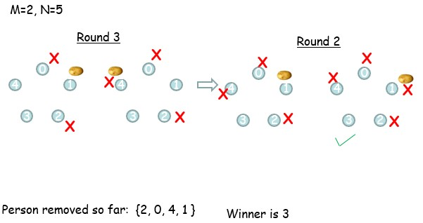

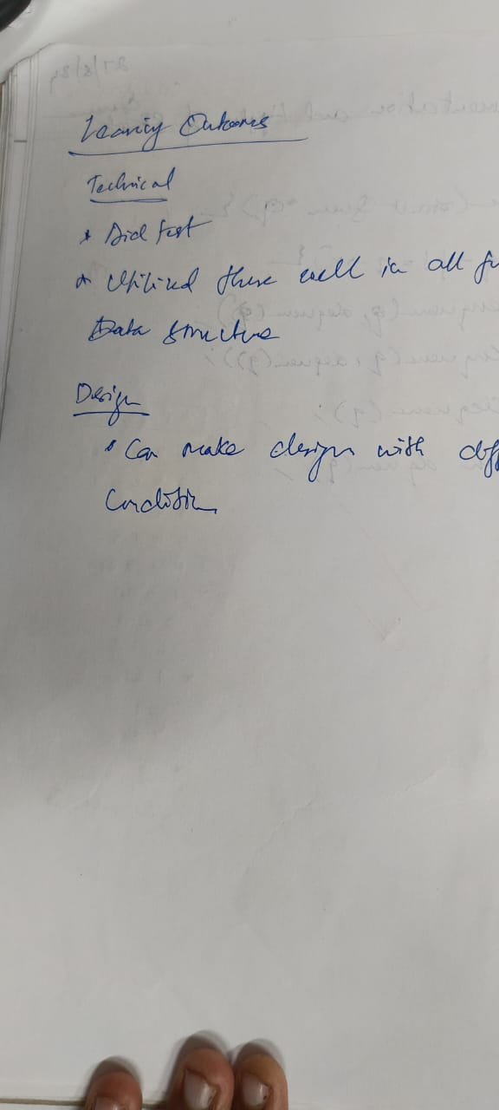

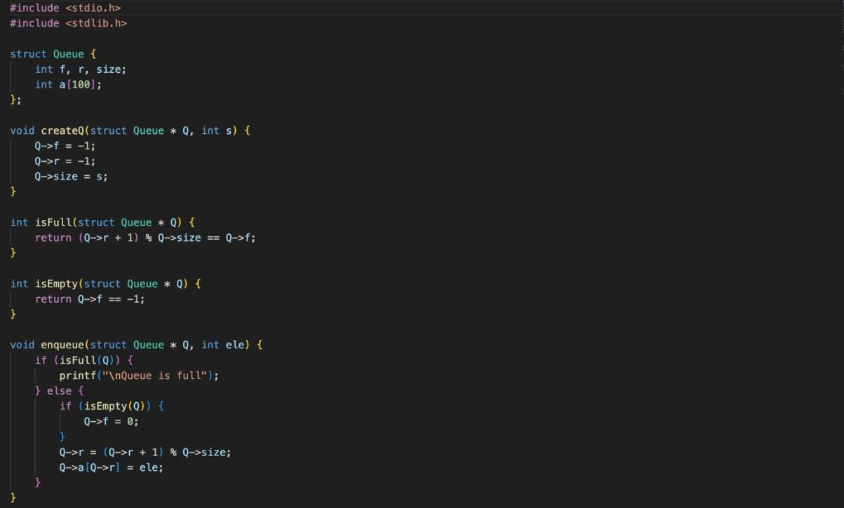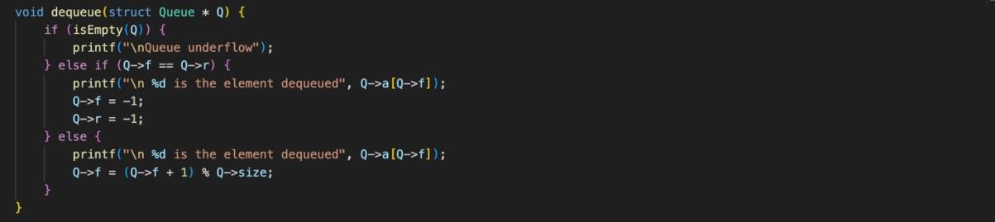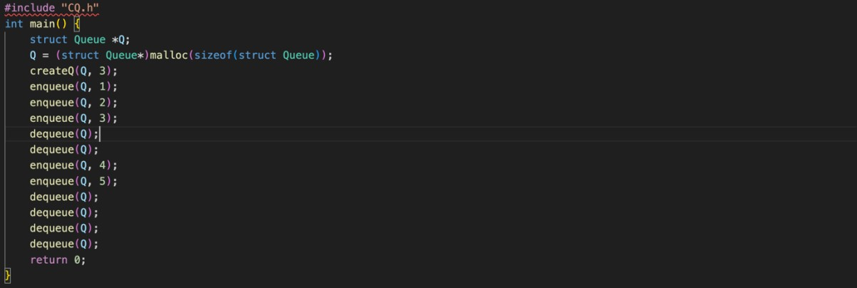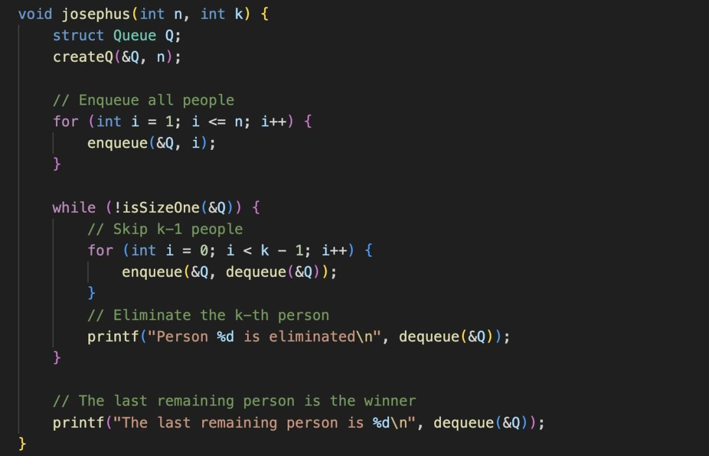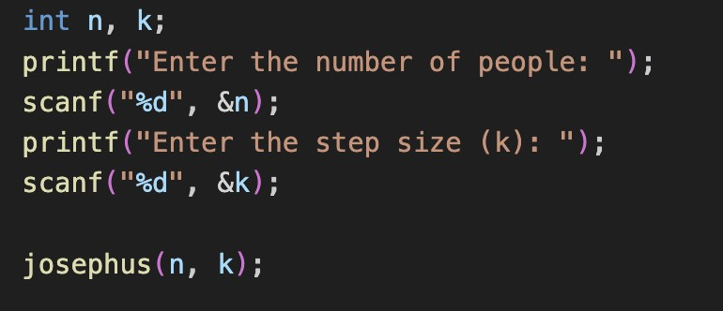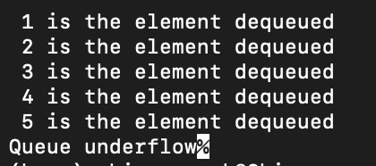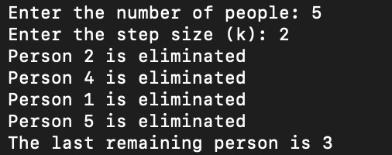

Technical Outcomes

|  |  |  |
| --- | --- | --- |
| Design | 2 | Needs improvement |
| Understanding of DS | 3 |  |
| Use of DS | 3 |  |
| Debugging | 3 |  |

Best Practices

|  |  |  |
| --- | --- | --- |
| Design before coding | 2 | Needs improvement |
| Usage of Algo | 3 |  |
| Multifile | 3 |  |
| Versioning | 3 |  |

**UCS 2312 Data Structures Lab**

**Assignment 5: BSTADT and its application**

Create an ADT for the binary search tree data structure with the following functions. Each node which consists of integer data, address of left and right children.

[CO2, K3]

1. insertBST(t,data) – insert data into BST
2. inorder(t) – display the tree using inorder traversal
3. preorder(t) – display the tree using preorder traversal
4. postorder(t) – display the tree using postorder traversal
5. levelorder(t) – display the tree hierarchically
6. findmin(t)– returns the minimum element in the tree
7. search(t,key) – returns the element found, otherwise returns NULL
8. delete(t,elt) – delete the given elt from tree

1. Demonstrate the BSTADT with the following test

case

Insert(t,29)

Insert(t,23)

Insert(t,4)

Insert(t,13)

Insert(t,39)

Insert(t,31)

Insert(t,45)

Insert(t,56)

Insert(t,49)

Inorder(t) → 4,13,23,29,31,39,45,49,56 Levelorder(t)→ 1st Level → 29

2nd level → 23, 39

3rd Level →4, 31, 45

4th Level →13, 56

5th Level → 49 Findmin(t) → 4

Find(t, 13) → Found, value is

3 Find(t,3) → Not found

2. Write an application to do the following

a. Given a sorted array. Write a function that creates a Balanced Binary Search Tree using array elements.

Examples:

Input: arr[] = {1, 2, 3}

Output: A Balanced BST

2

/ \

1 3

Explanation: all elements less than 2 are on the left side of 2 , and all the elements greater than 2 are on the right side

Input: arr[] = {1, 2, 3, 4}

Output: A Balanced BST

3

/ \ 2 4

/

1

b. Given a Binary Search Tree (BST), find the second largest element.

**Example:**

***Input:*** *Root of below BST*

*10*

*/*

*5*

# Output: 5

***Input:*** *Root of below BST*

*10*

*/ *

*5 20*

*\*

*30*

# Output: 20

1. Count the number of nodes in tree within the given range
2. Find sum of k smallest elements in the given BST
3. Test case for the

Application (a)

Input: Tree 1

10

/ \

5 50

/ / \

1 40 100 Input: Tree2

10

/ \

5 50

/ / \

1 40 100

Tree1 and Tree2 are identical with a set of elements (b) Tree1 not complete (c) Tree1 Range: [**5**, 45] Output: 3

Nodes are 5, 10, 40

Tree2 Range: [**1**, 45]

Output: 4

Nodes are 1,5, 10, 40

Given two binary search trees root1 and root2, return *a list containing all the integers from both trees sorted in* **ascending**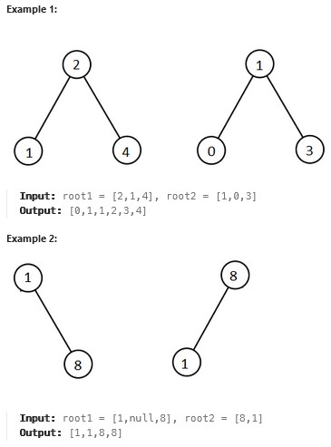

Write a function to check whether the given tree is BST

**Best practices to be followed:**

* Design before coding
* Usage of algorithm notation
* Use of multi-file C program
* Versioning of code

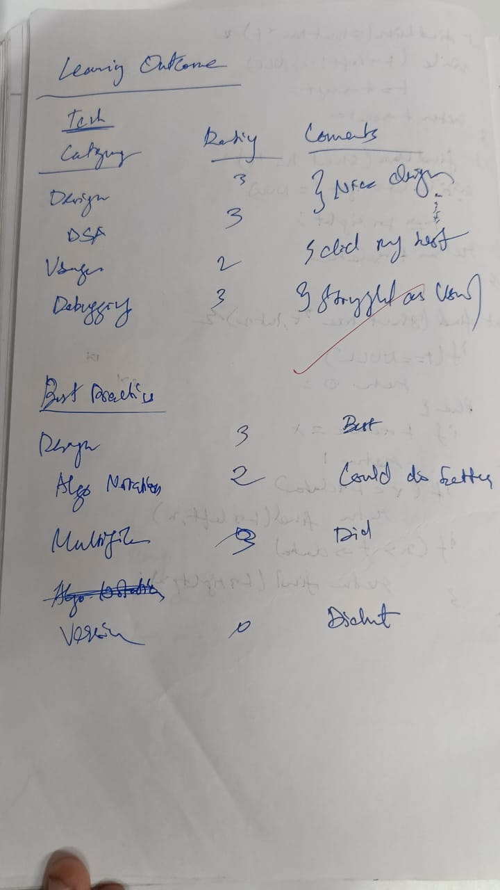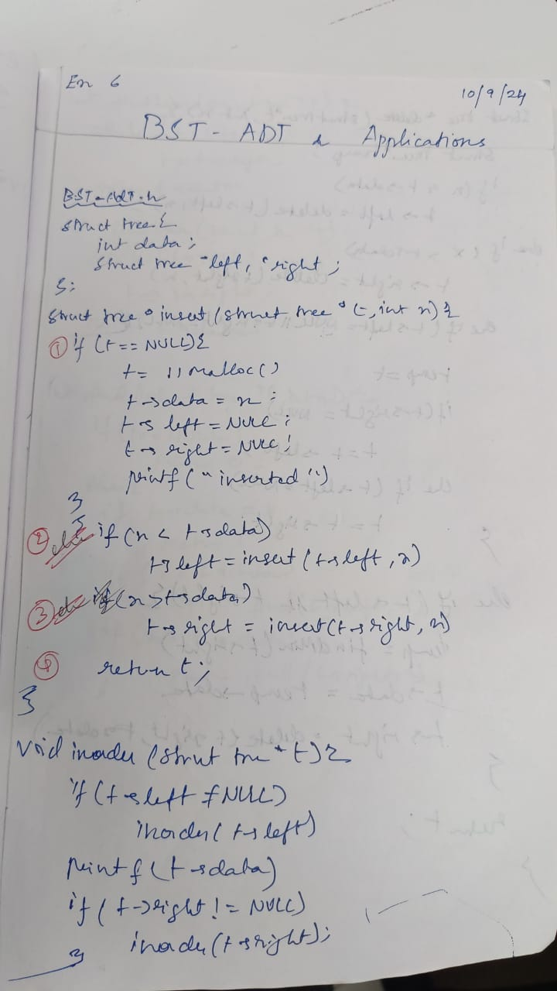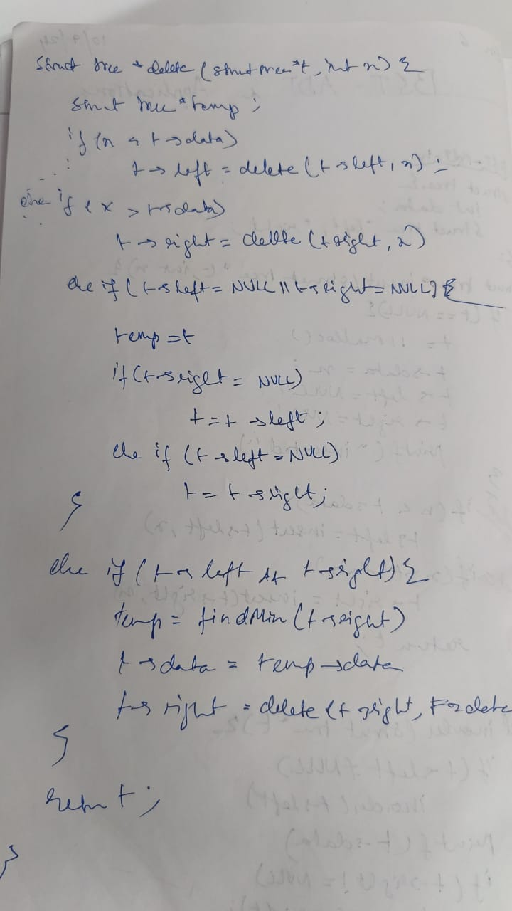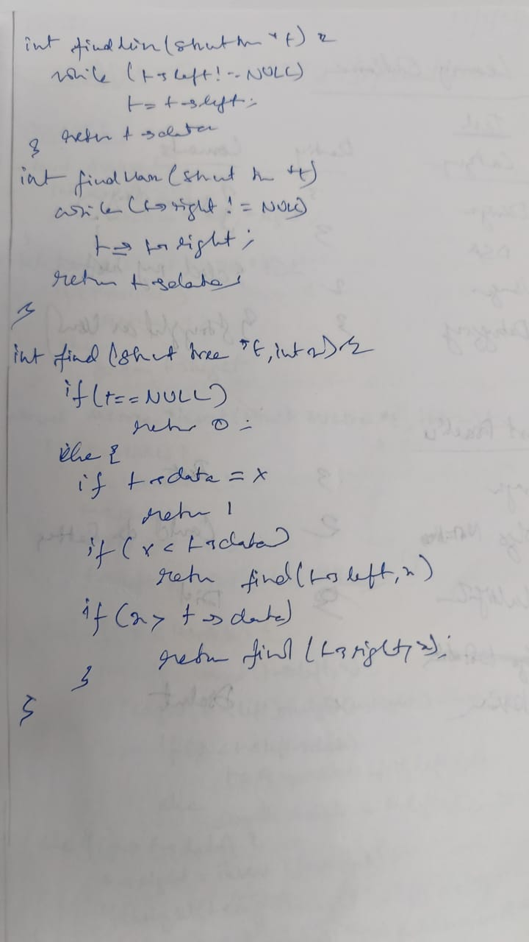

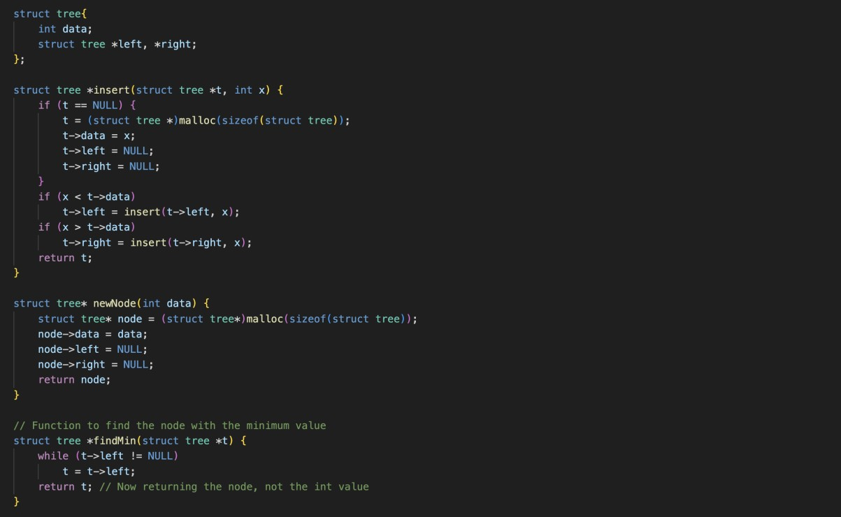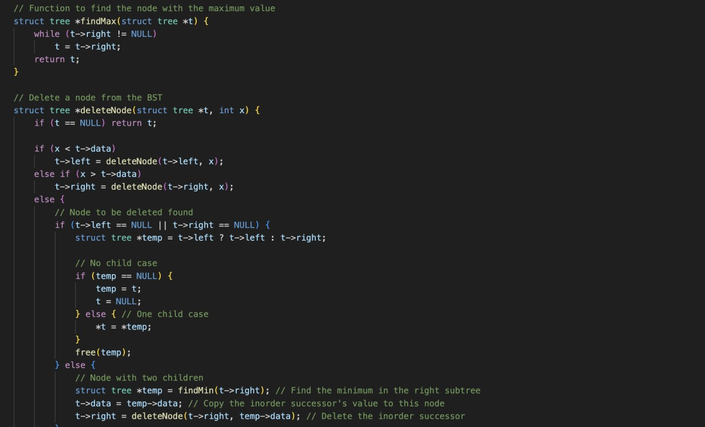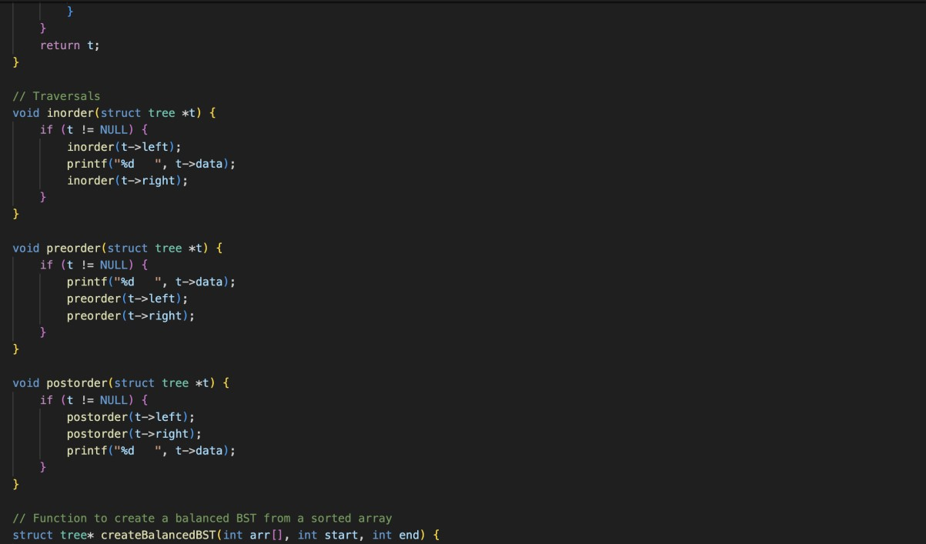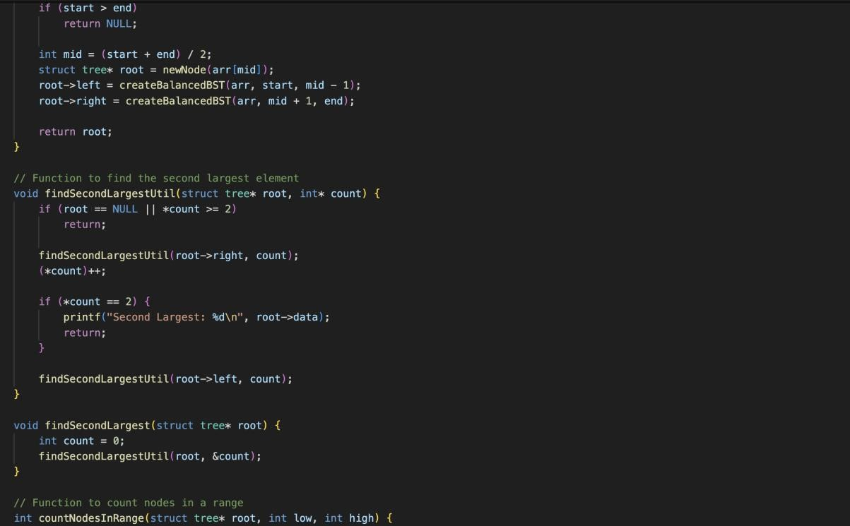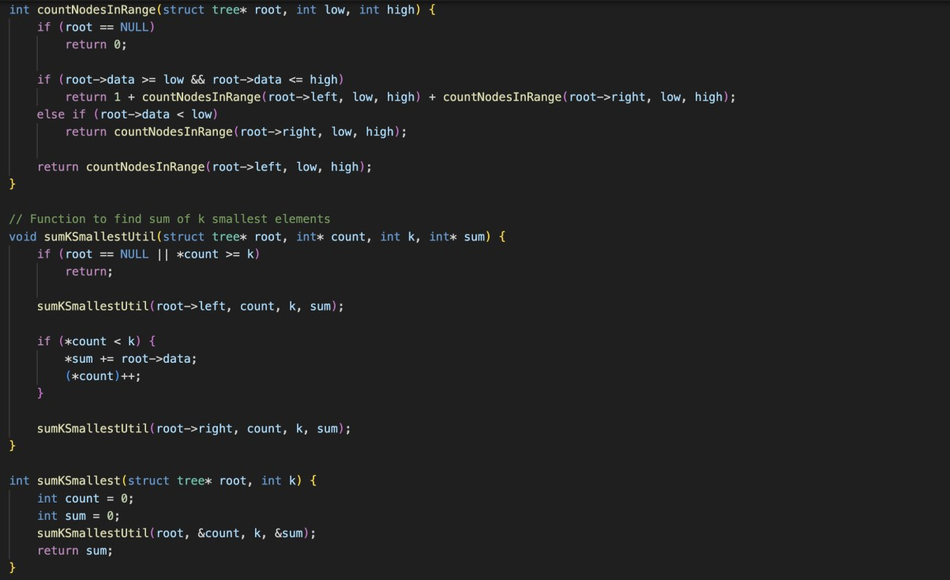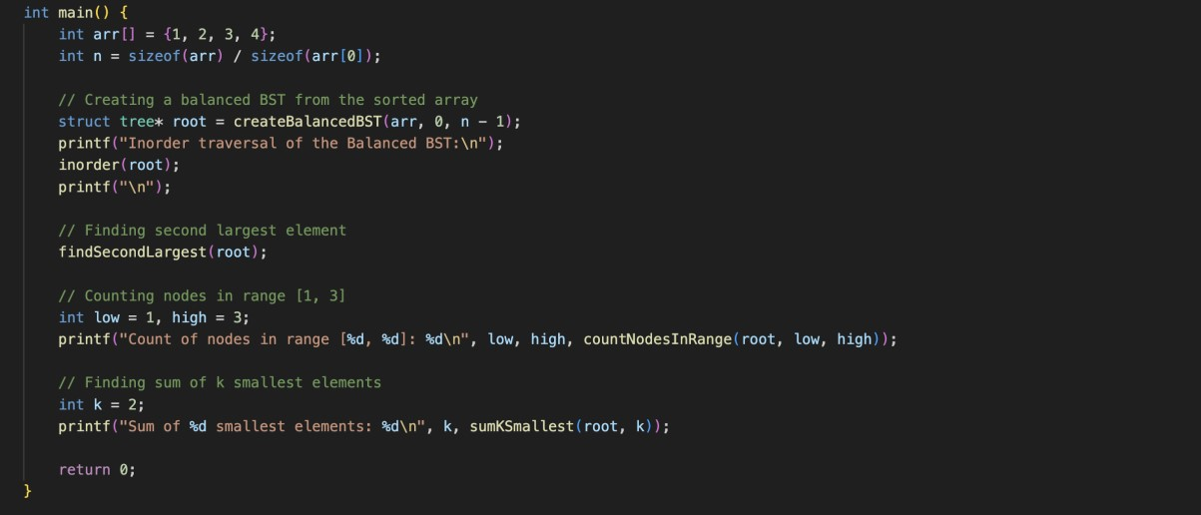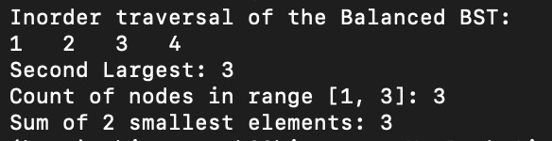

Technical Outcomes

|  |  |  |
| --- | --- | --- |
| Design | 2 | Needs improvement |
| Understanding of DS | 2 | Needs improvement |
| Use of DS | 3 |  |
| Debugging | 3 |  |

Best Practices

|  |  |  |
| --- | --- | --- |
| Design before coding | 2 | Needs improvement |
| Usage of Algo | 3 |  |
| Multifile | 1 | Needs improvement |
| Versioning | 3 |  |

**UCS 2312 Data Structures Lab**

**Assignment 7: Implementation of AVL Tree**

Design an ADT for the AVL Tree data structure with the following functions. Each node consists of a character data, address of left, right and parent nodes [CO1, K3]

1. insertAVL(t, data) – insert data into BST
2. hierarchical(t) – display the tree in hierarchical fashion
3. findParent(t, key) – will return the parent of the given data
4. findLeaf(t) – returns the number of leaf nodes
5. findDepth(t,x) – returns the depth of the node x

Demonstrate the AVL ADT with the insertion of the following character data one at a time.

**H, I, J, B, A, E, C, F, D, G, K, L**

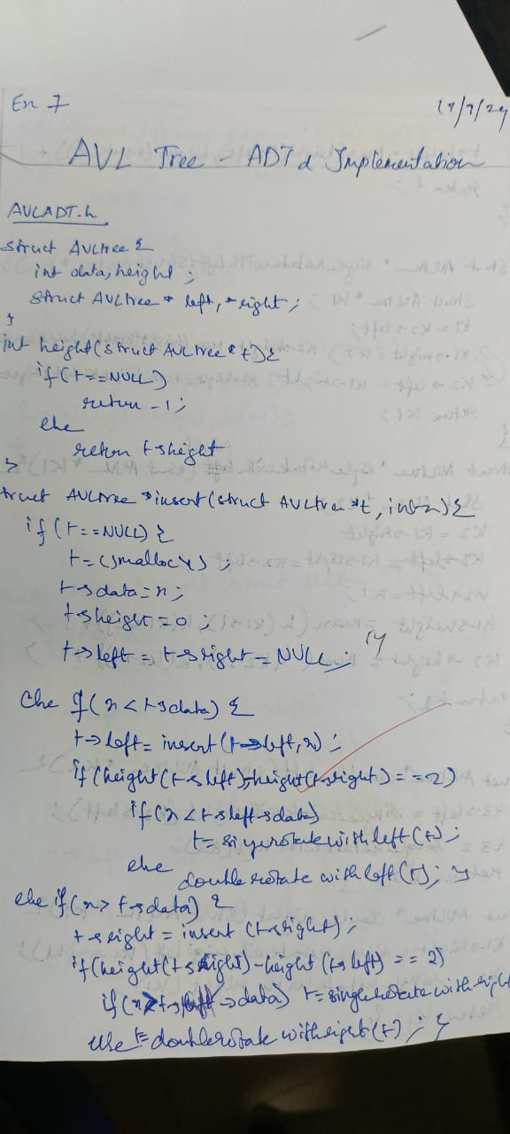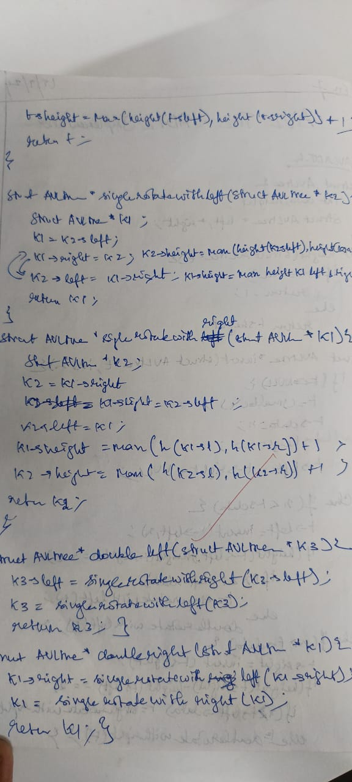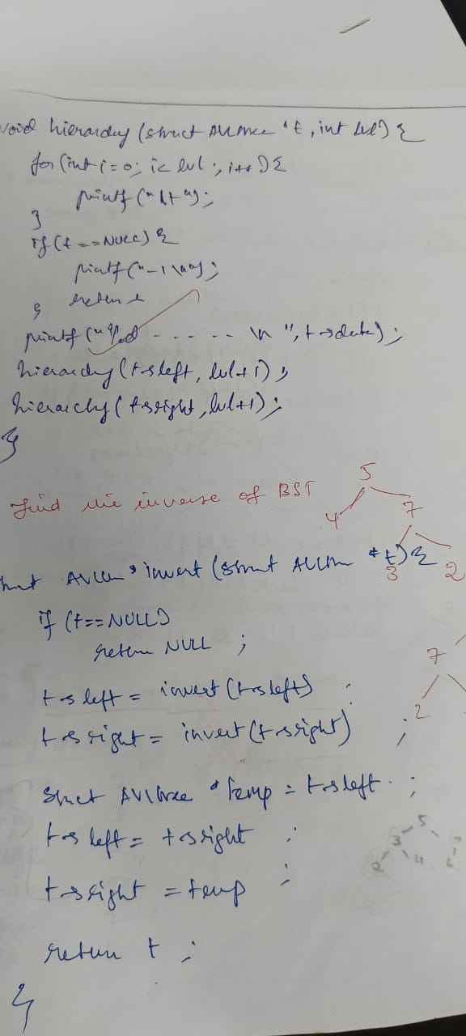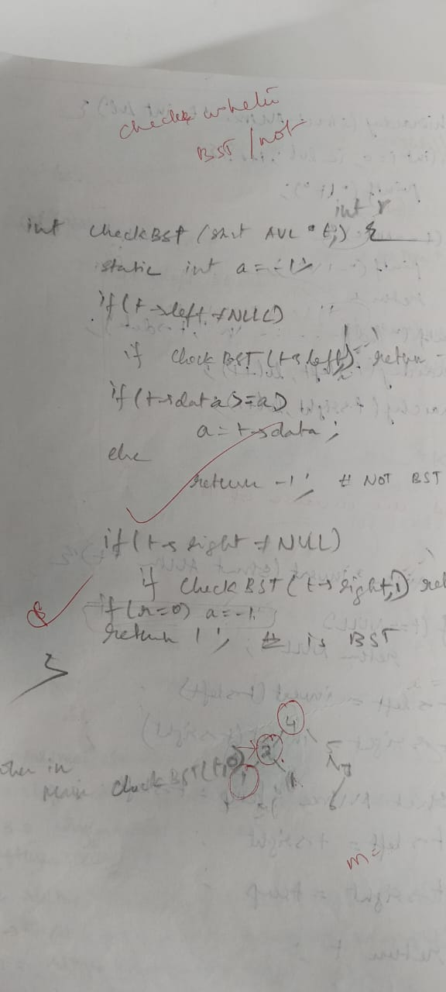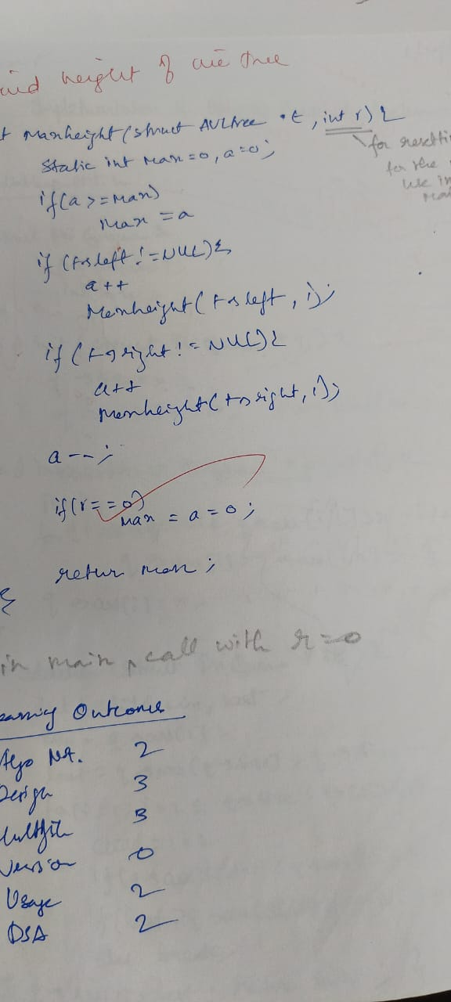

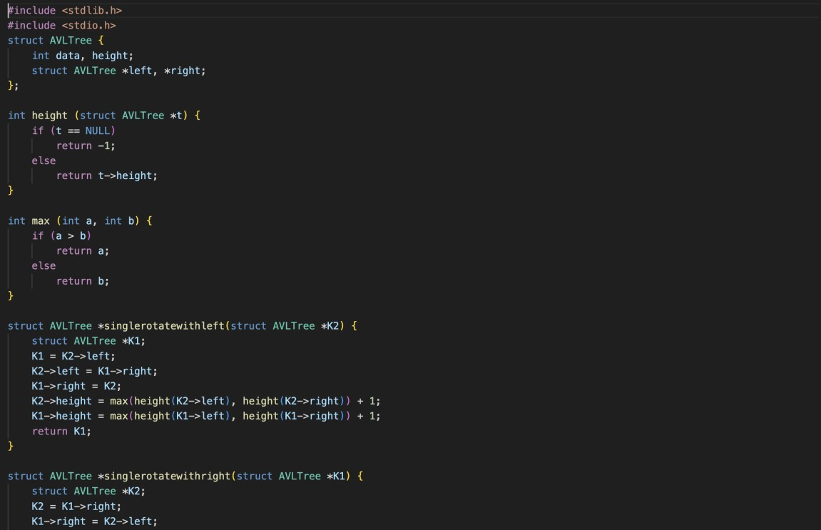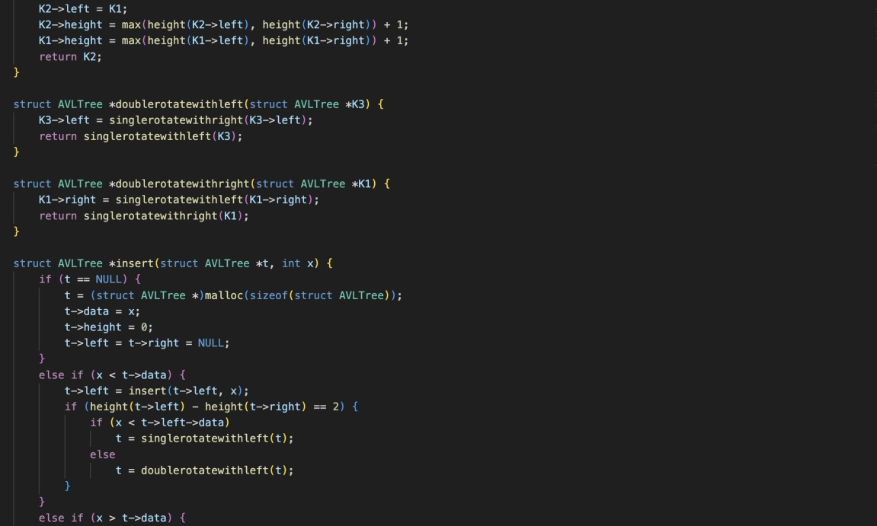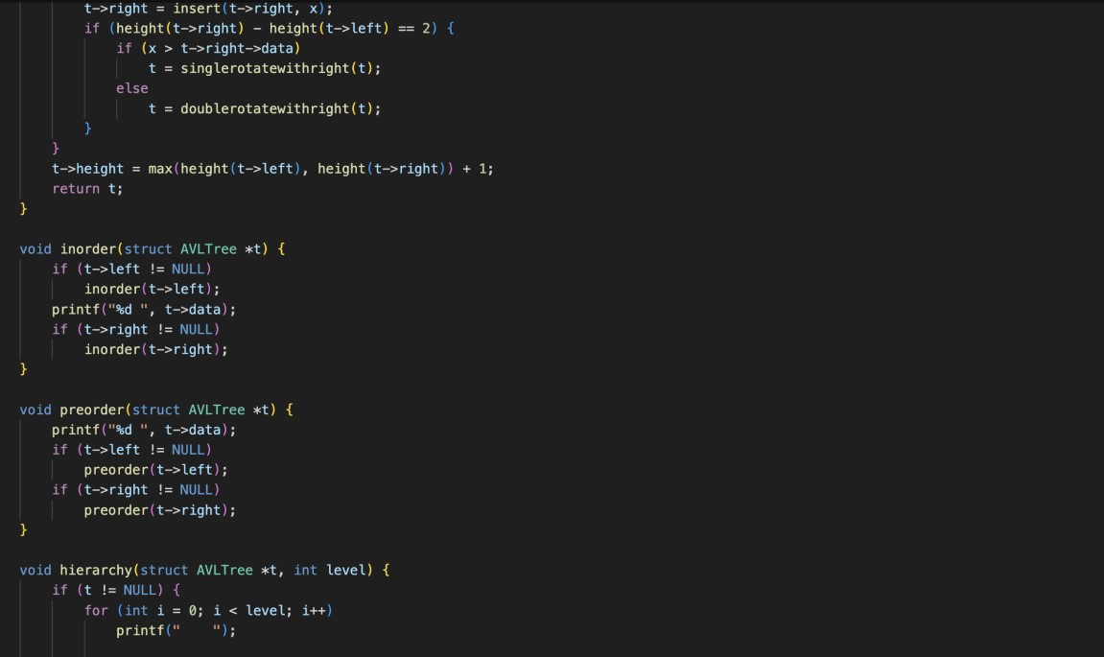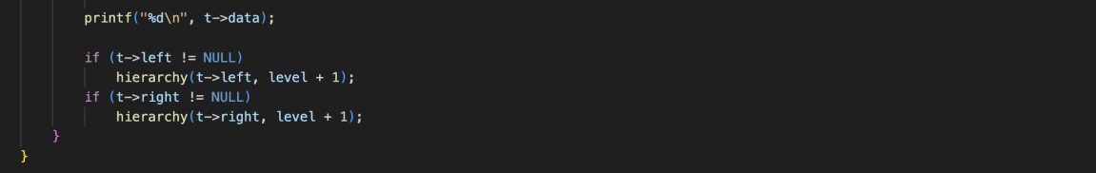

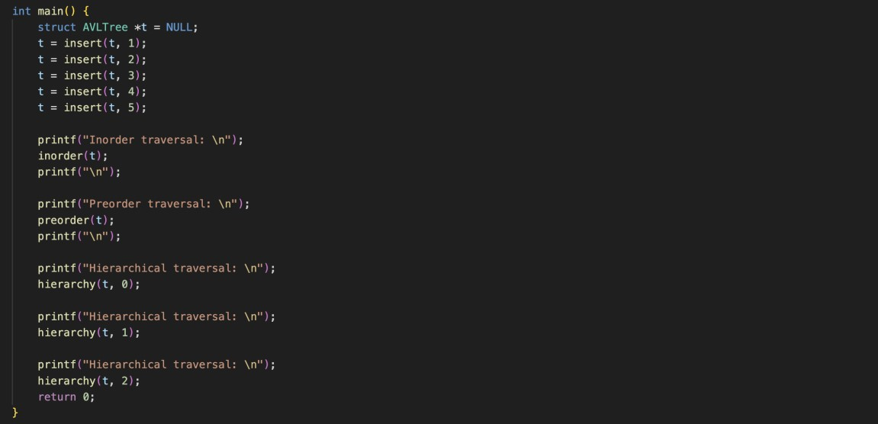

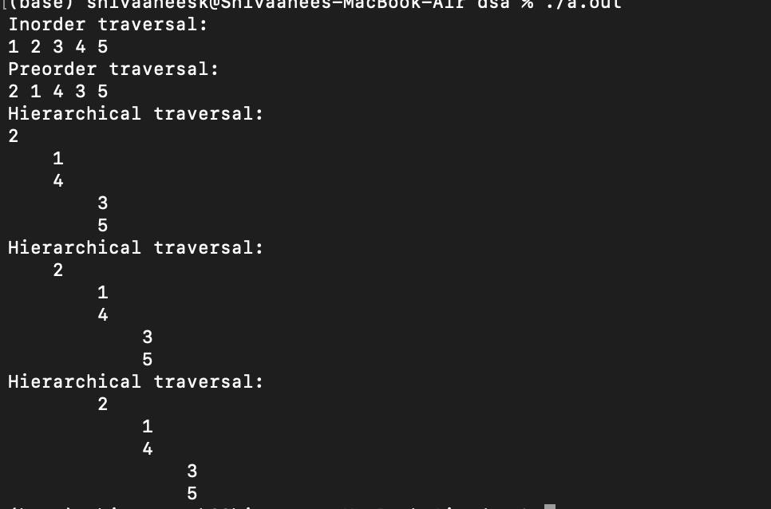

Technical Outcomes

|  |  |  |
| --- | --- | --- |
| Design | 2 |  |
| Understanding of DS | 2 | Needs improvement |
| Use of DS | 3 |  |
| Debugging | 2 |  |

Best Practices

|  |  |  |
| --- | --- | --- |
| Design before coding | 2 | Needs improvement |
| Usage of Algo | 2 |  |
| Multifile | 3 |  |
| Versioning | 0 | didnt |

**UCS 2312 Data Structures Lab**

**Assignment 8: Binary Heap and its applications**

Implement Priority Queue using Binary Heap. priorityQueueADT consists of integer element.

Implement the following methods.

[CO2, K3]

* void insert(struct priorityQueueADT *P, int x) – Insertion new item into priority queue using Max Heap property
* int delete(struct priorityQueueADT *P) – Will remove the root of binary heap
* void display(struct priorityQueueADT *P) – Will display the contents pf Priority Queue

1. Demonstrate ADT with the following testcase insert(p,14); insert(p,16); insert(p,22); insert(p,11); insert(p,9); insert(p,18); insert(p,10); insert(p,7); insert(p,4);

insert(p,1);

1. Write an application to design a priority queue using max binary heap. An item in the priority queue consists of employee id and salary amount. The queue supports two operations, namely, insertion and deletion.

Test the application with the following insert(p,(‘A’,15000)); insert(p,(’K’,12000)); insert(p,(‘R’,4000)); insert(p,(‘T’,3500)); insert(p,(‘L’,4600)); insert(p,(‘P’,6000));

insert(p,(‘Y’,8600));

Output:

Employees are removed in the following order

(‘A’,15000), (’K’,12000), (‘Y’,8600), (‘P’,6000), (‘L’,4600), (‘R’,4000), (‘T’,3500),

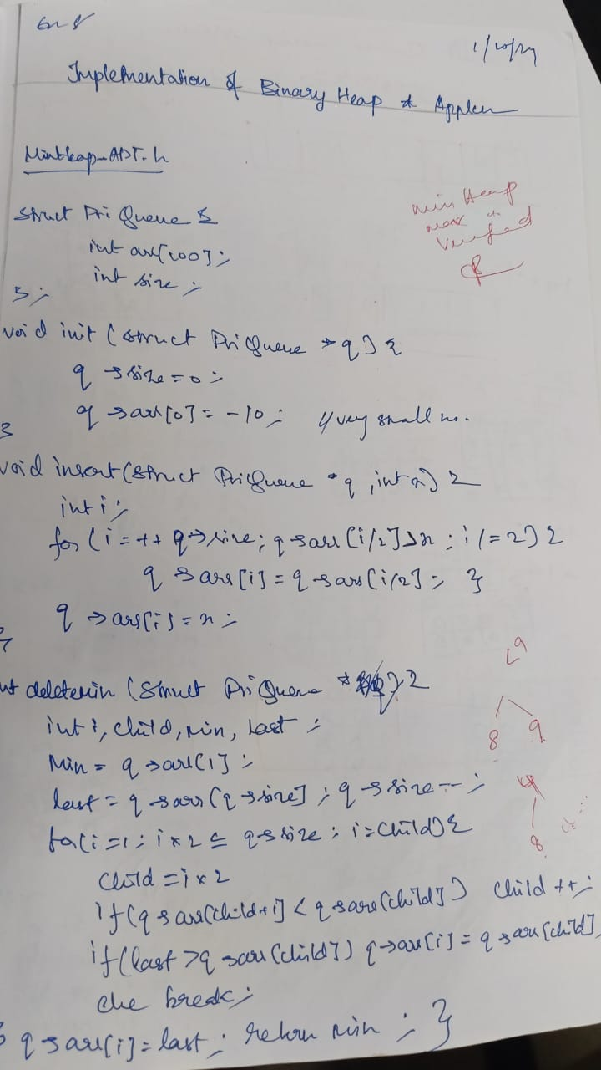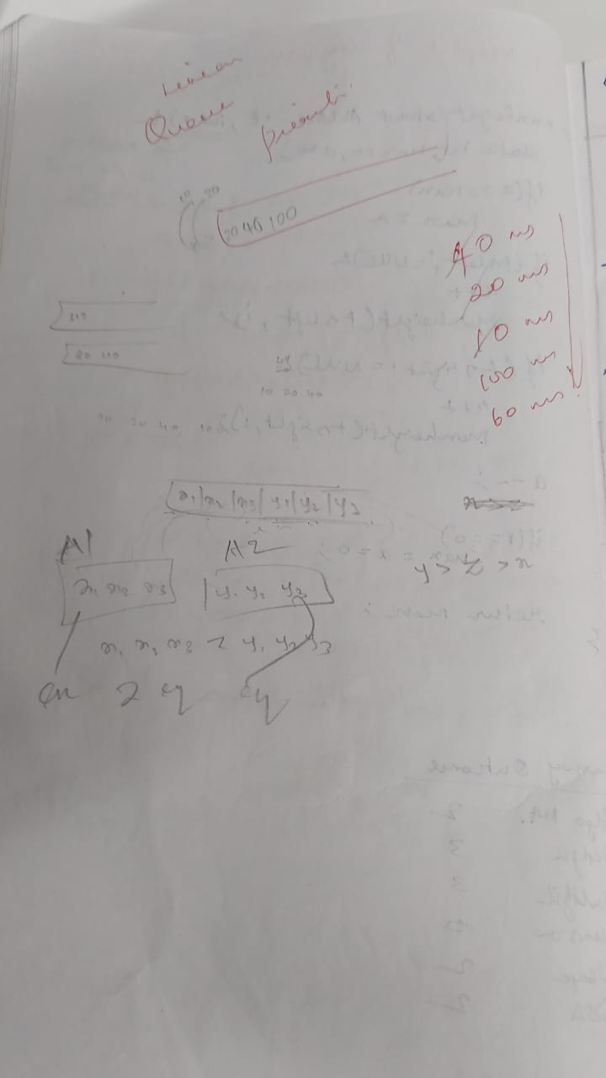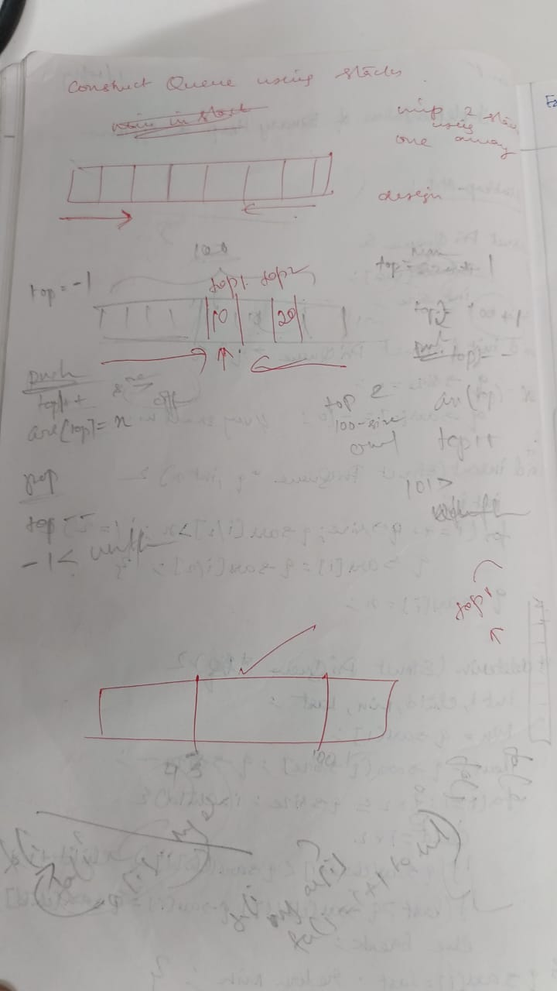

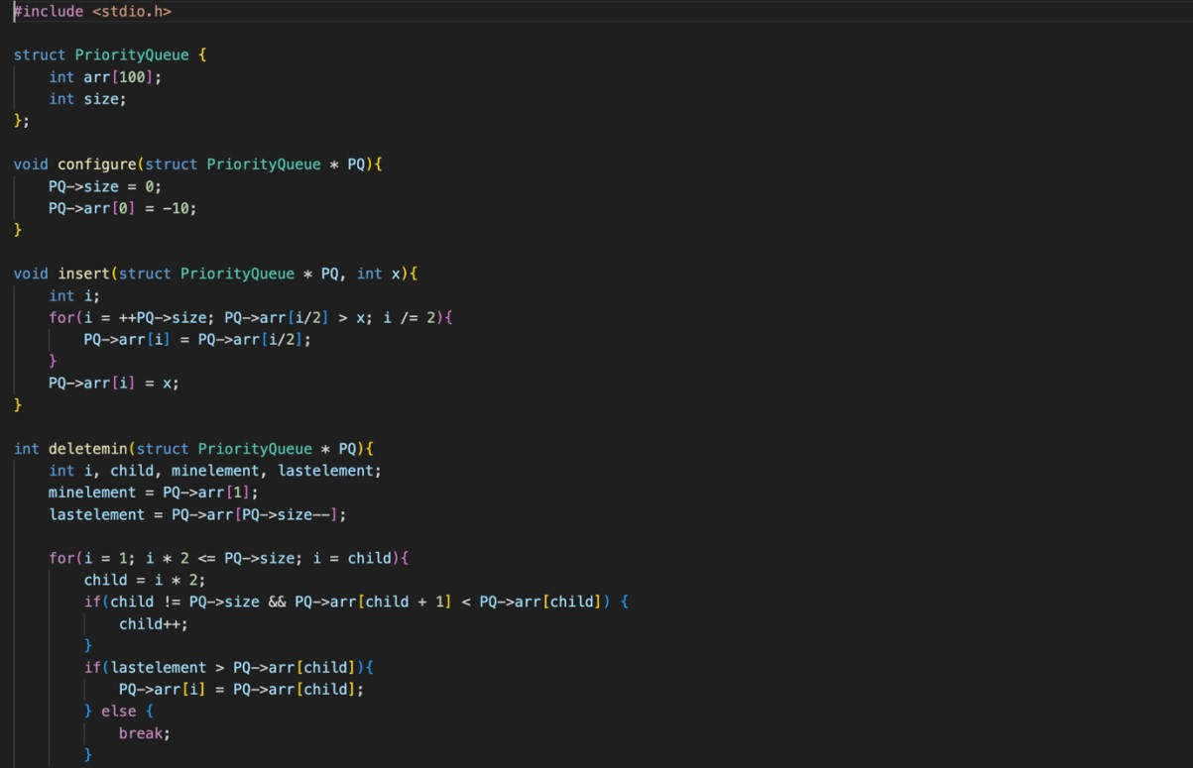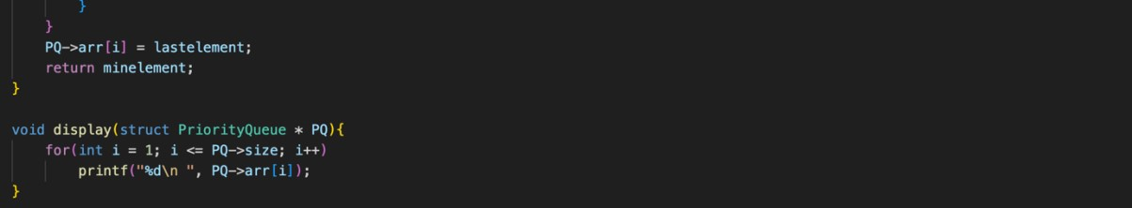

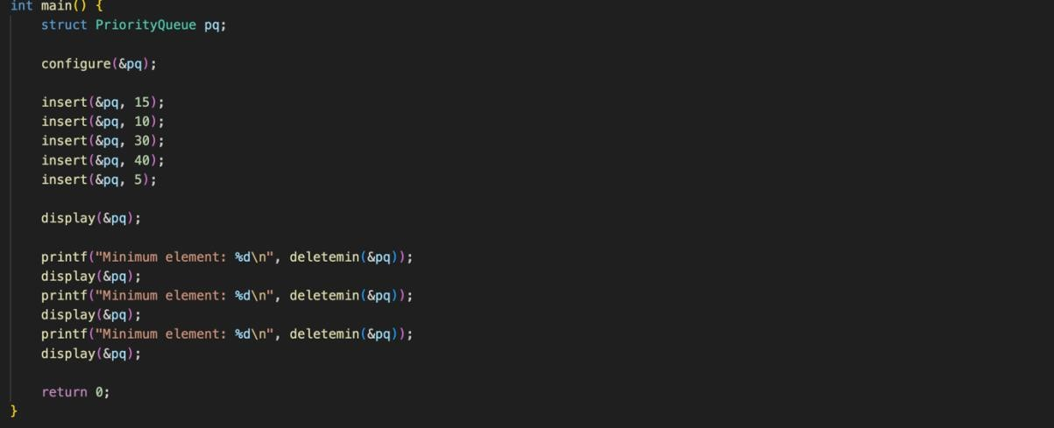

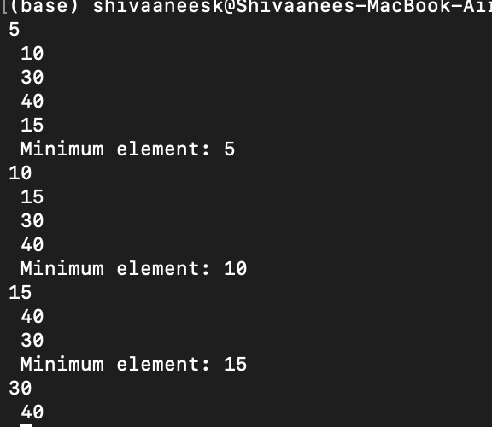

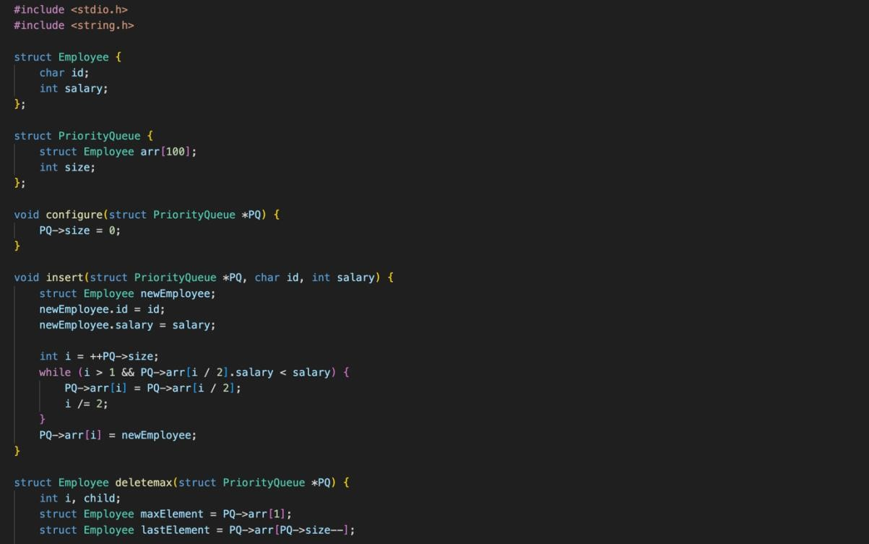

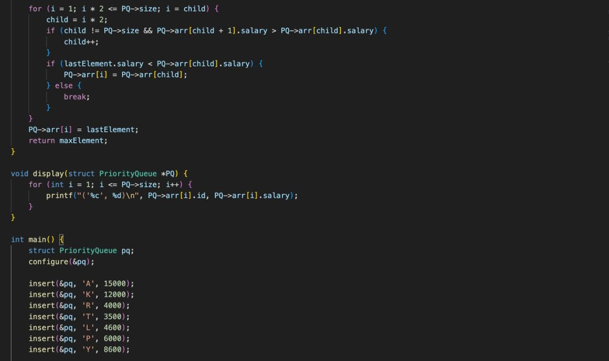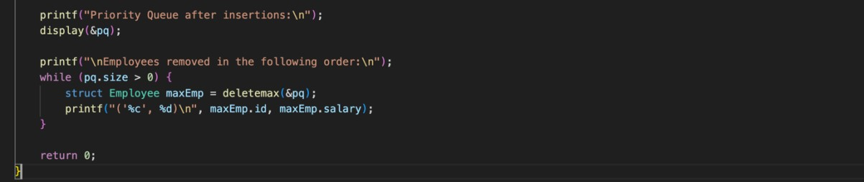

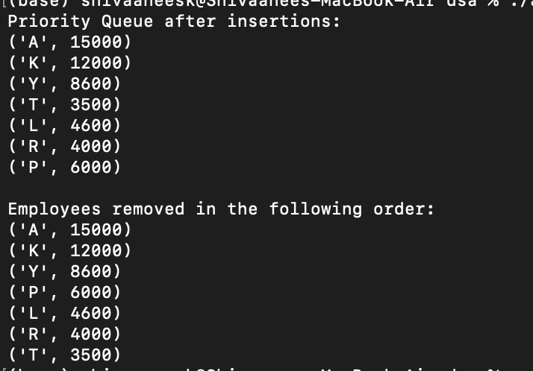

Technical Outcomes:

|  |  |  |
| --- | --- | --- |
| Design | 3 |  |
| Understanding DS | 3 |  |
| Usage of DS | 2 | Needs improvement |
| Debugging | 3 |  |

Best Practices:

|  |  |  |
| --- | --- | --- |
| Design before coding | 3 |  |
| Usage of algo | 3 |  |
| Multifile | 2 | Needs improvement |
| versioning | 3 |  |

**UCS 2312 Data Structures Lab**

**Assignment 9: Graph Traversal and its Applications**

The cityADT consists of adjacency matrix that represents the connection between the cities. Adjacency matrix has an entry 1, if there is a connection between the cities.

Implement the following methods. [CO2, K3]

* void create(cityADT *C) – will create the graph using adjacency matrix
* void disp(cityADT *C) – display the adjacency matrix
* void BFS(cityADT *C) – provides the output of visiting the cities by following breadth first
* void DFS(cityADT *C) – provides the output of visiting the cities by following depth first

1. Demonstrate the ADT with the following Graph

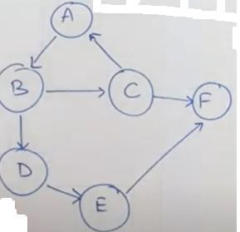

Enter the no. of vertices: 6

Enter the no. of edges: 7

AB, BC, BD, CA, CF, DE, EF

Adjacency Matrix

|  |  |  |  |  |  |  |
| --- | --- | --- | --- | --- | --- | --- |
|  | A | B | C | D | E | F |
| A | 0 | 1 | 0 | 0 | 0 | 0 |
| B | 0 | 0 | 1 | 1 | 0 | 0 |
| C | 1 | 0 | 0 | 0 | 0 | 1 |
| D | 0 | 0 | 0 | 0 | 1 | 0 |
| E | 0 | 0 | 0 | 0 | 0 | 1 |
| F | 0 | 0 | 0 | 0 | 0 | 0 |

**BFS Output:** ABCDFE for Start vertex A

**DFS Output:** ABCFDE for Start vertex A

1. Write an application to utilize traversals to do the following:

* 1. Given the source and destination cities, find whether there is a path from source to destination
  2. Find the connected components in a given graph

Test the application with the following Input:

Source: D Destination: F Output:

Path exists Input:

Source: F Destination: B Output:

Path not exists

Input:

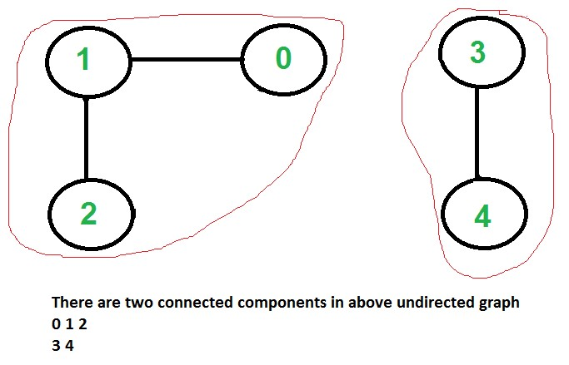

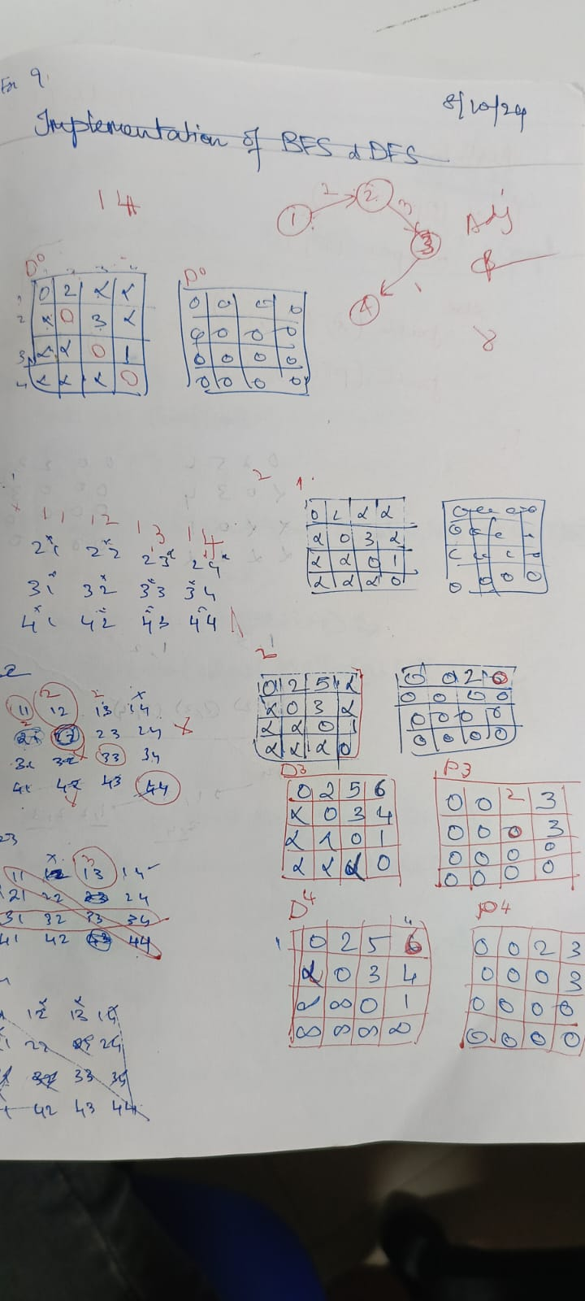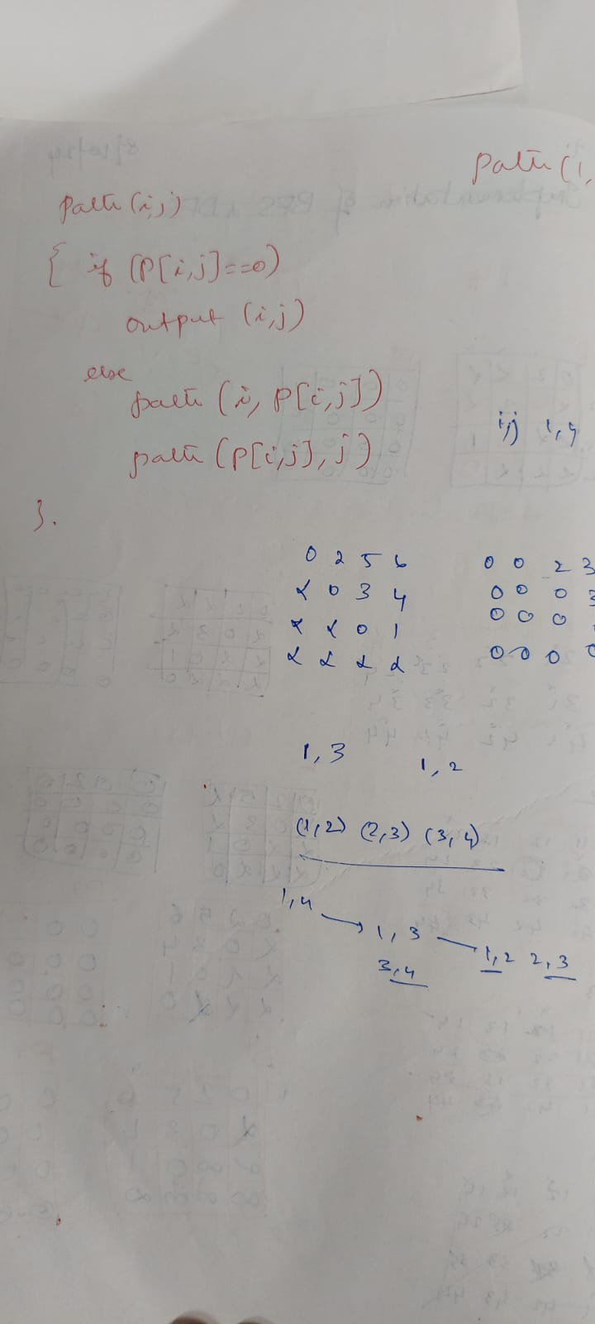

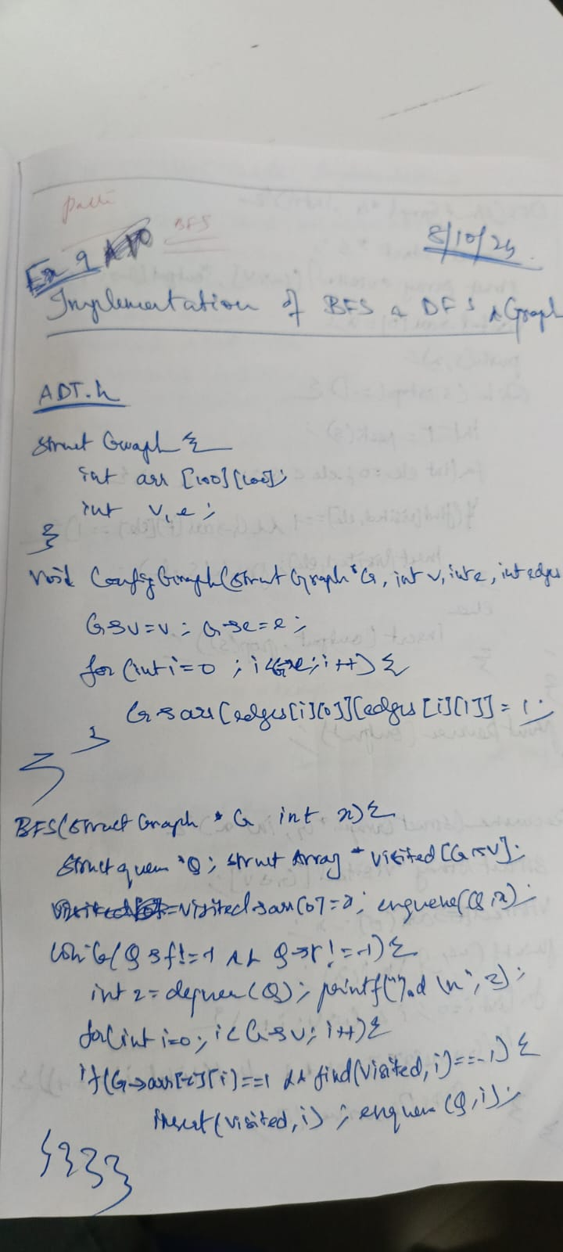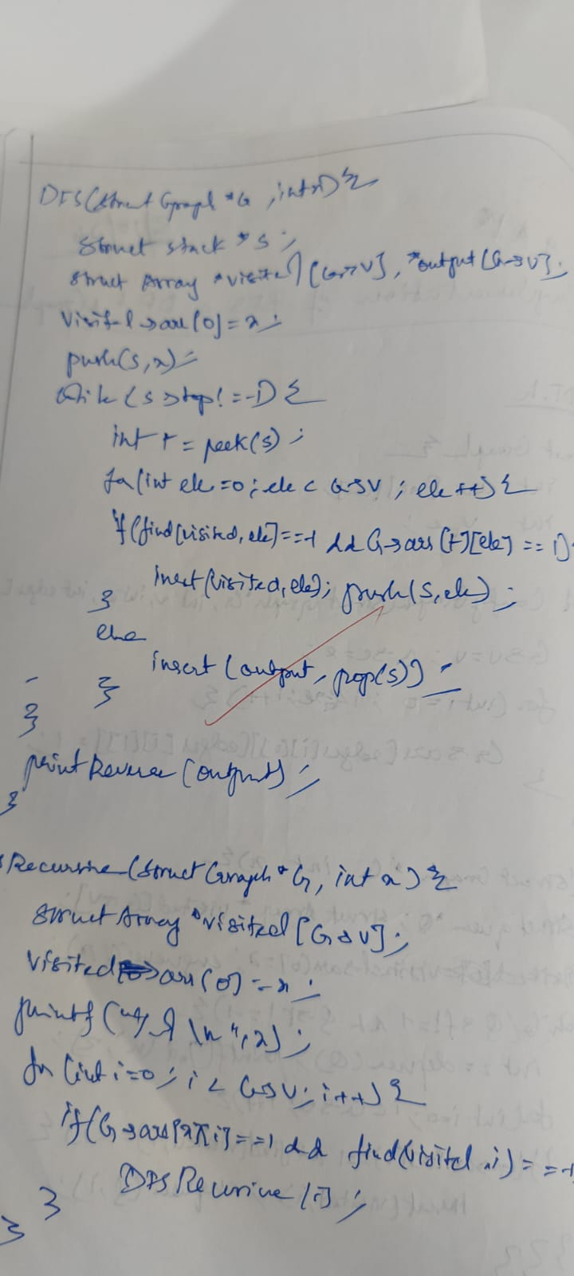

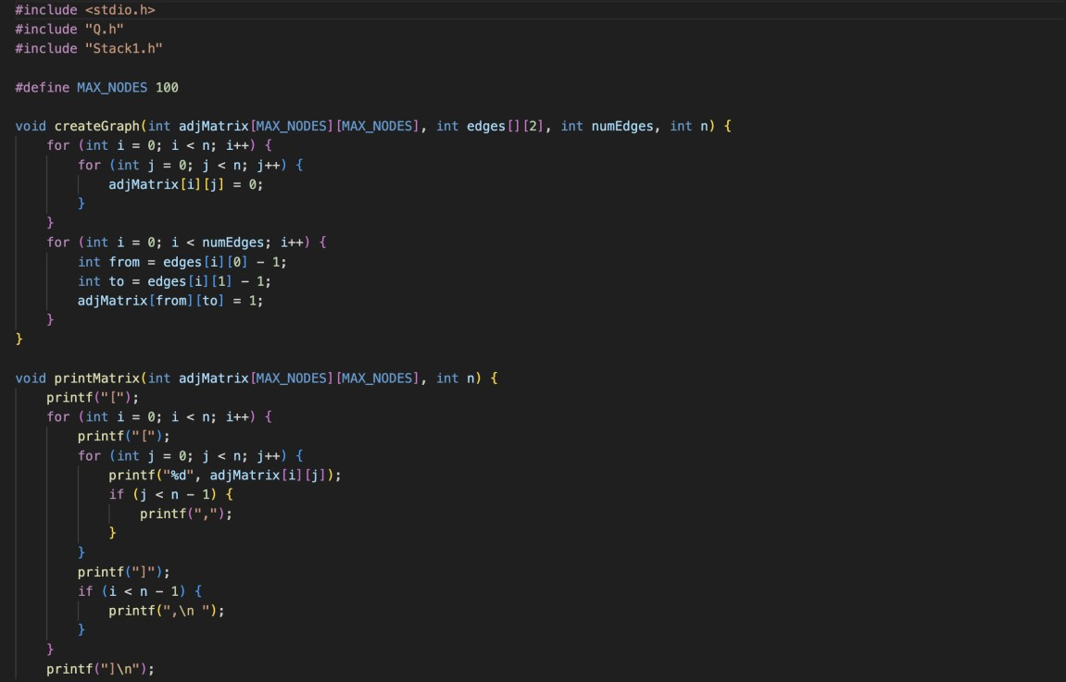

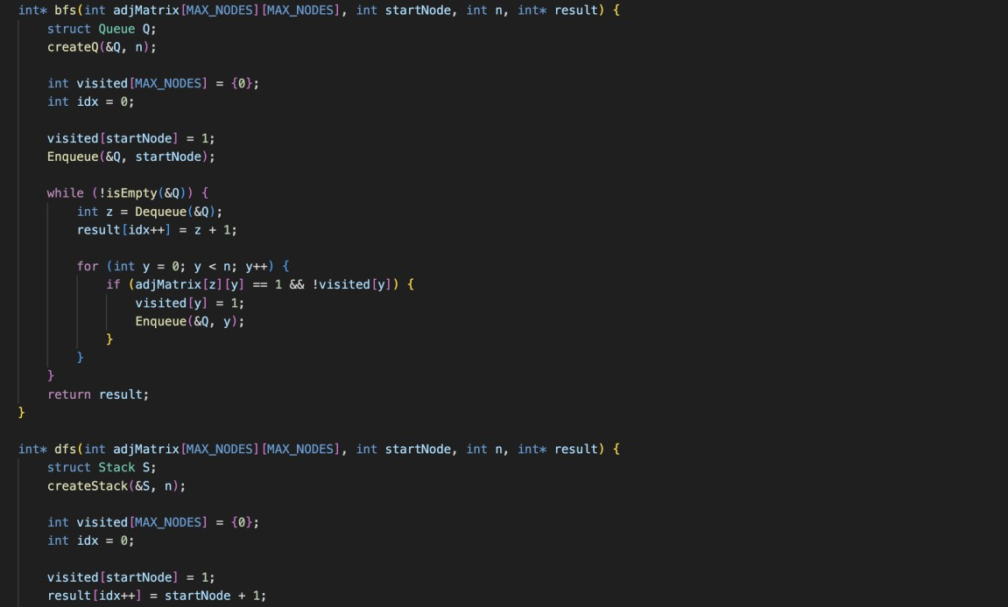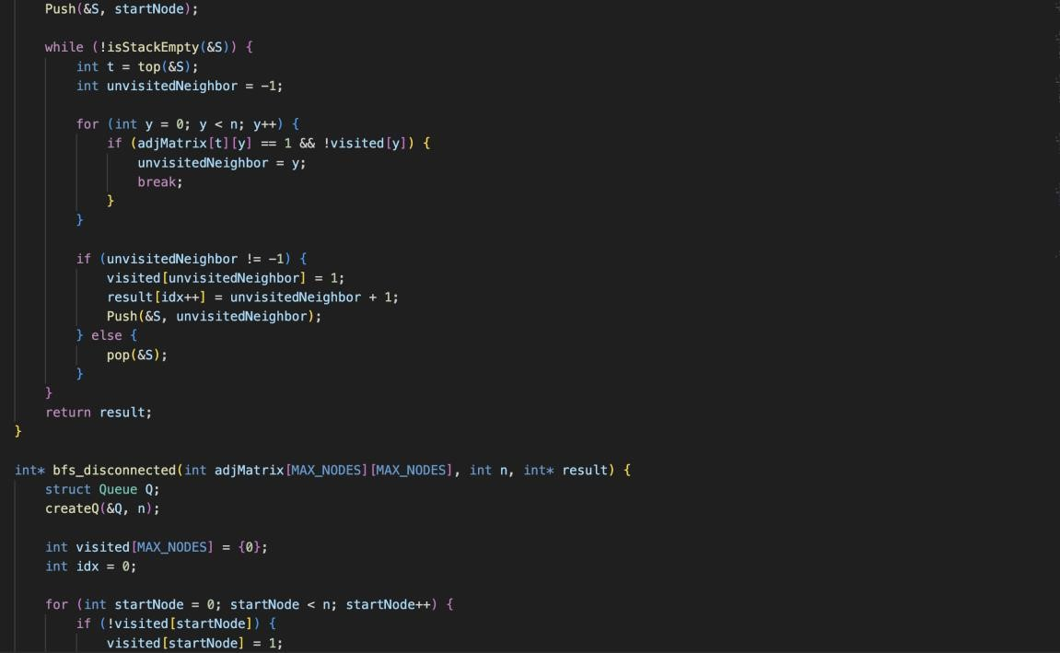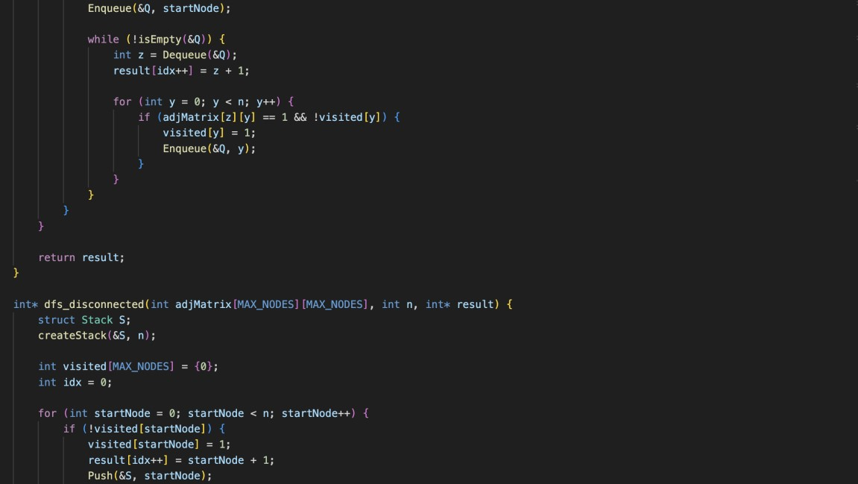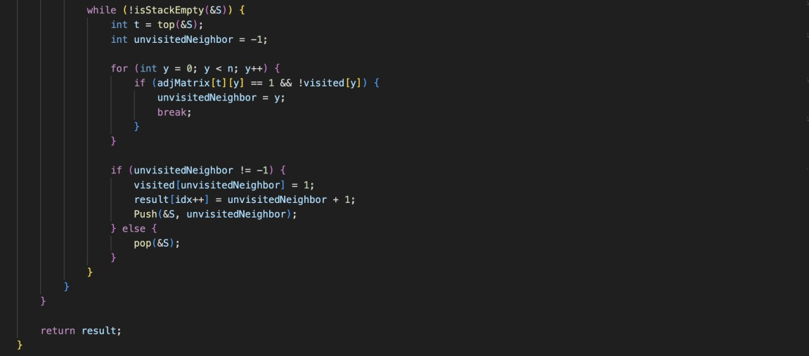

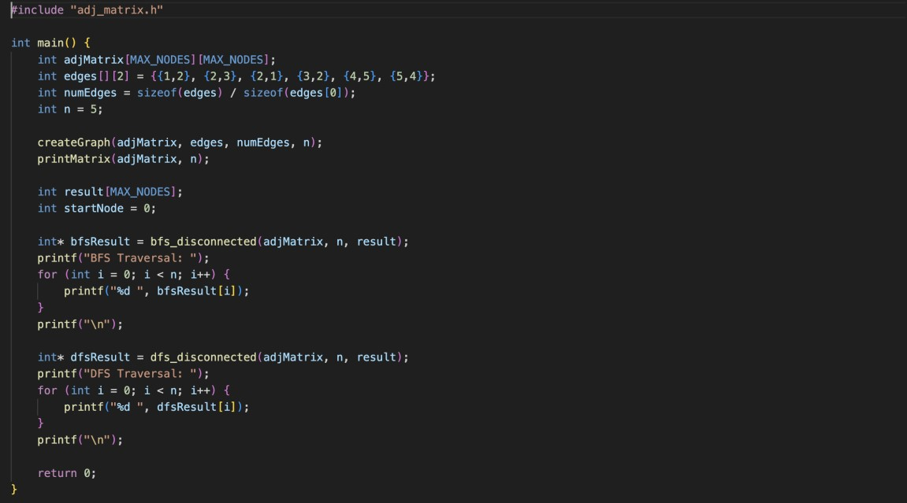

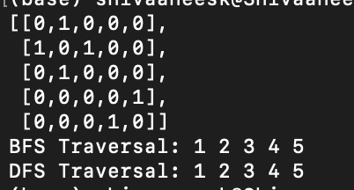

Technical Outcomes:

|  |  |  |
| --- | --- | --- |
| Design | 3 |  |
| Understanding DS | 3 |  |
| Usage of DS | 2 | Needs improvement |
| Debugging | 3 |  |

Best Practices:

|  |  |  |
| --- | --- | --- |
| Design before coding | 3 |  |
| Usage of algo | 3 |  |
| Multifile | 3 |  |
| versioning | 3 |  |

**UCS 2312 Data Structures Lab**

**Assignment 10: Implementation of Shortest Path Finding algorithm**

The cityADT contains the number of cities and the connectivity information between the cities (adjacency matrix). Write the following methods. [CO2, K3]

* void create(cityADT *C) – will represent the graph using adjacency matrix
* void disp(cityADT *C) – Display the graph
* void Dijkstra(cityADT *C)
  + Displays the intermediate and final tables
* char * displayPath(cityADT *C, source, destination)
  + Find the path of the intermediate cities between the source and destination cities along with the cost

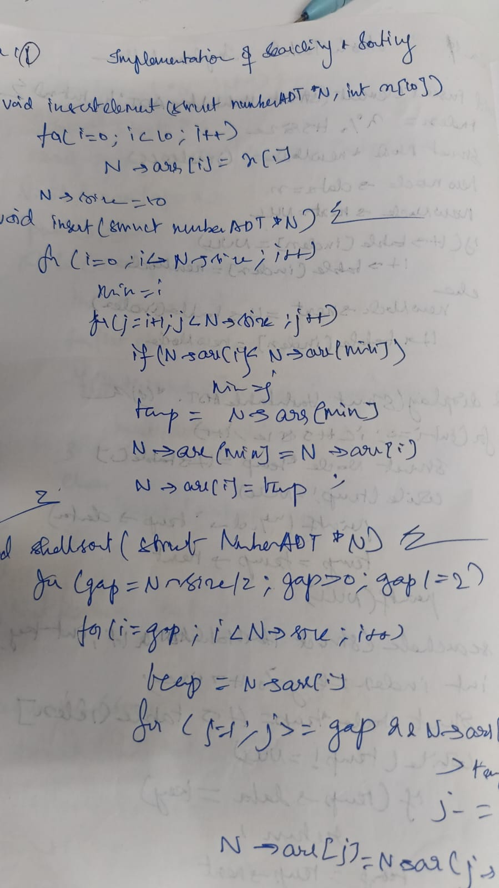

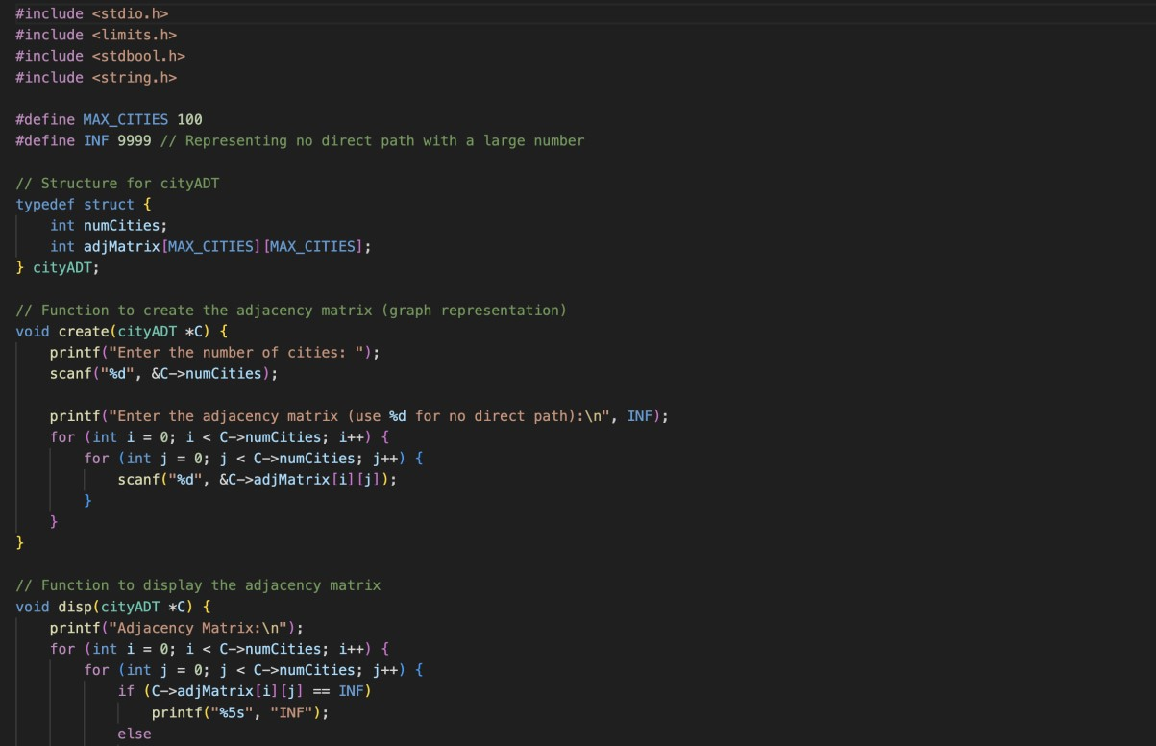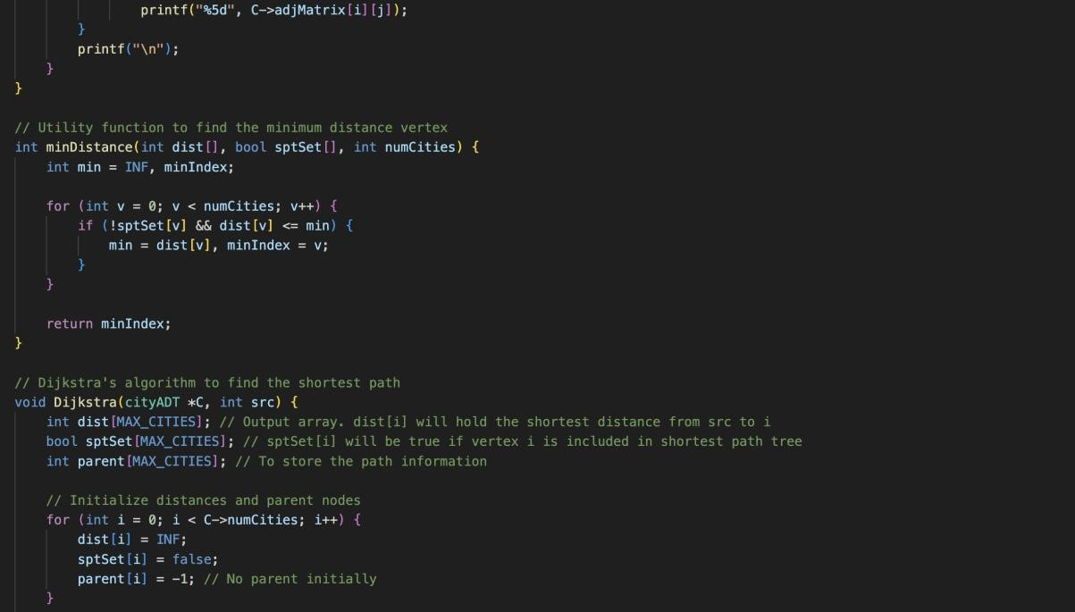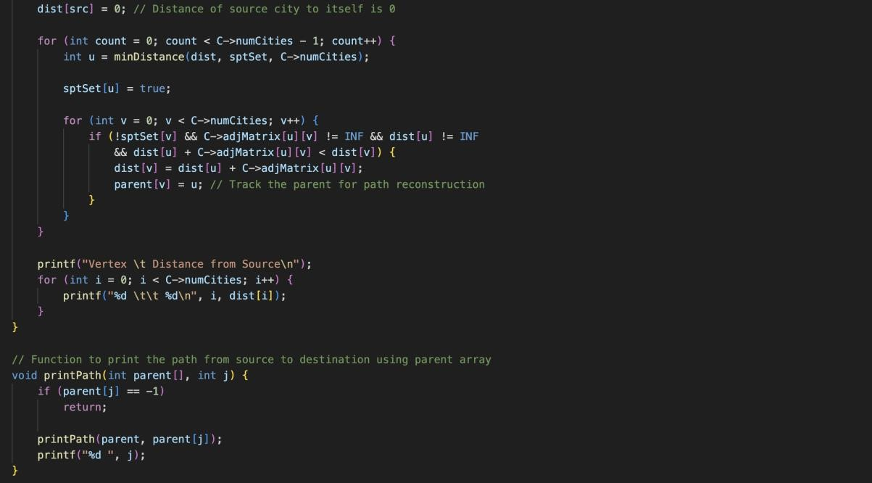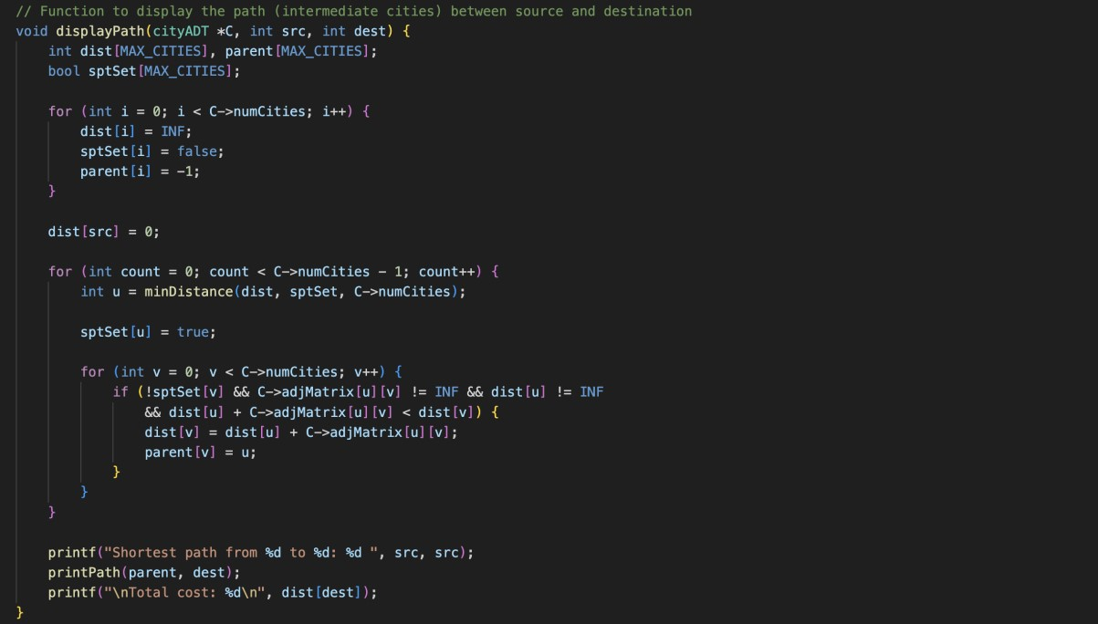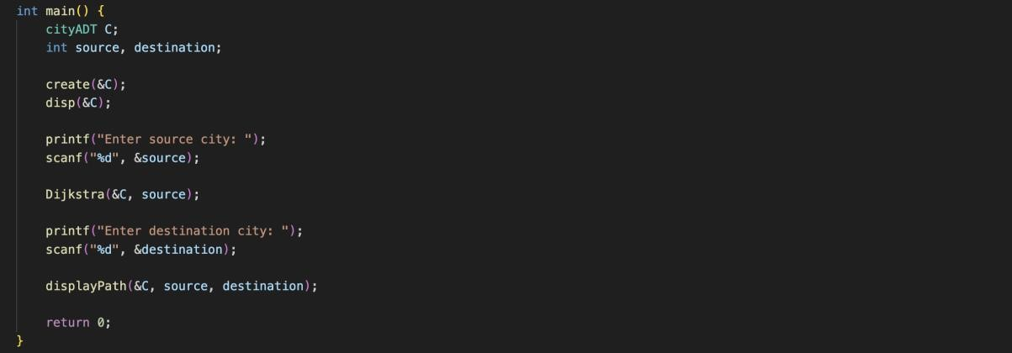

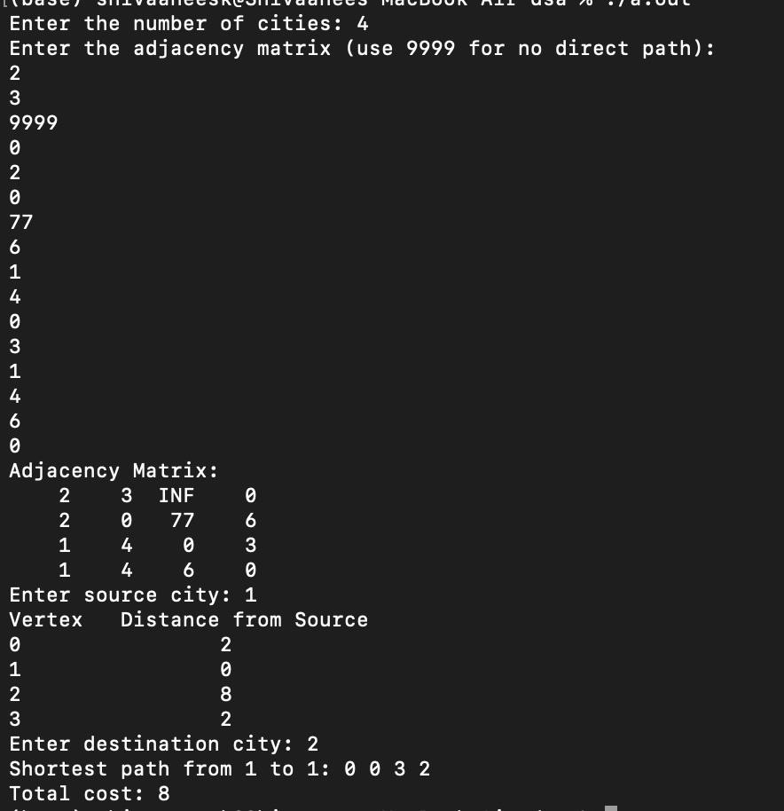

Technical Outcomes:

|  |  |  |
| --- | --- | --- |
| Design | 2 | Needs improvement |
| Understanding DS | 2 | Needs improvement |
| Usage of DS | 2 |  |
| Debugging | 3 |  |

Best Practices:

|  |  |  |
| --- | --- | --- |
| Design before coding | 2 |  |
| Usage of algo | 2 |  |
| Multifile | 3 |  |
| versioning | 3 |  |

**UCS 2312 Data Structures Lab**

**Exercise 11: Implementation of Hash Table using Closed and Open addressing methods**

**[CO2, K3]**

The HashTableADT contains hash table and its size. Hash function to be used for the insertion of elements is ***x mod tableSize***. Use Separate chaining method to resolve the collision.

* void init(HashTableADT *H) – To initialize the size of Hash Table
* void insertElementL (HashTableADT *H, int x)– To insert the input key into the hash table
* int searchElement(HashTableADT *H, int key) – Searching an element in the hash table, if found return 1, otherwise return -1
* void displayHT(HashTableADT *H) – Display the elements in the hash table

**Note:**

1. Implement HashTableADT with the specified operations in HashTableADTImpl.h
2. Write a menu driven application to utilize the HashTableADT.

1. Demonstrate ADT with the following test case

insert 23, 45, 69, 87, 48, 67, 54, 66, 53

Contents of Hash Table

(Separate Chaining)

1. :
2. :
3. : 3 : 23 → 53
4. : 54
5. : 45
6. : 66
7. : 87 → 67
8. : 48
9. : 69

2. Create another hash table ADT with following functions for open addressing methods, namely, Quadratic probing and Double Hashing.

* void insertElementL (HashTableADT *H, int x)– To insert the input key into the hash table
* void displayHT(HashTableADT *H) – Display the elements in the hash table

Note: For Double hashing, the second hash function is 7-(x%7)

Demonstrate the ADT with the following testcase

(i) Contents of Hash Table

(Quadratic Probing)

1. →
2. →67
3. →53
4. →23
5. →54
6. →45
7. →66
8. →87
9. →48
10. →69

(ii) Contents of Hash Table

(Double Hashing)

1. →67
2. →
3. →53
4. →23
5. →54
6. →45
7. →66
8. →87
9. →48
10. →69

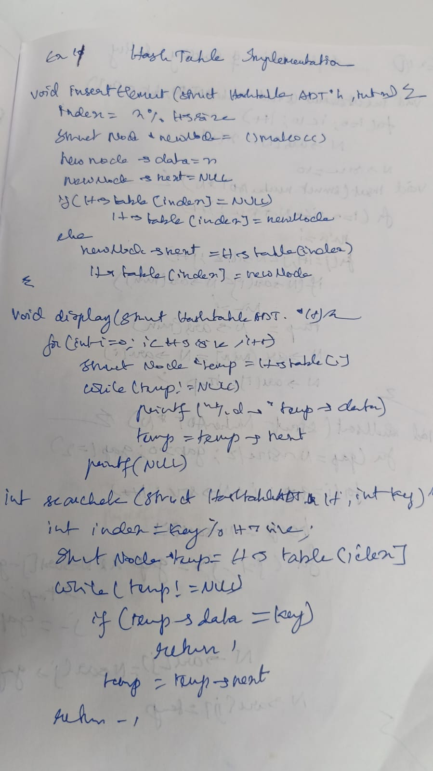

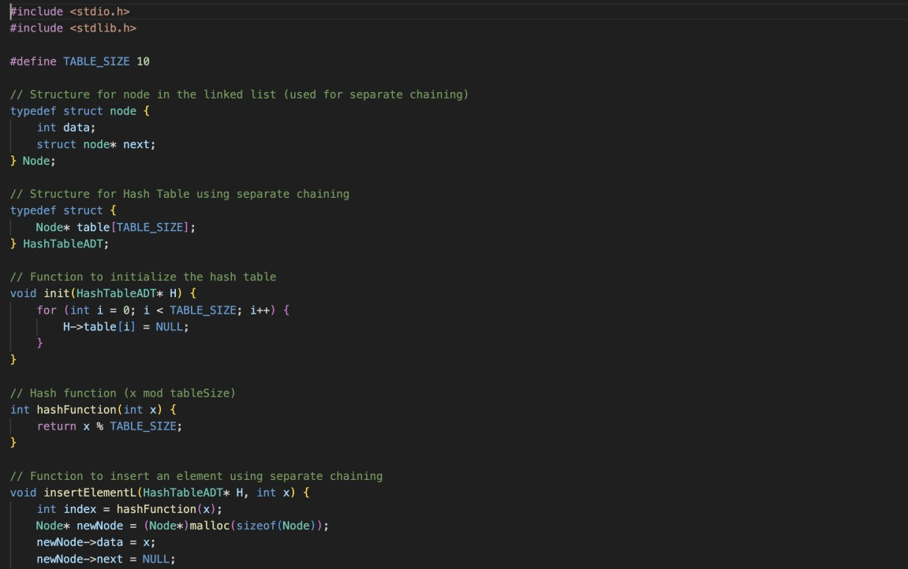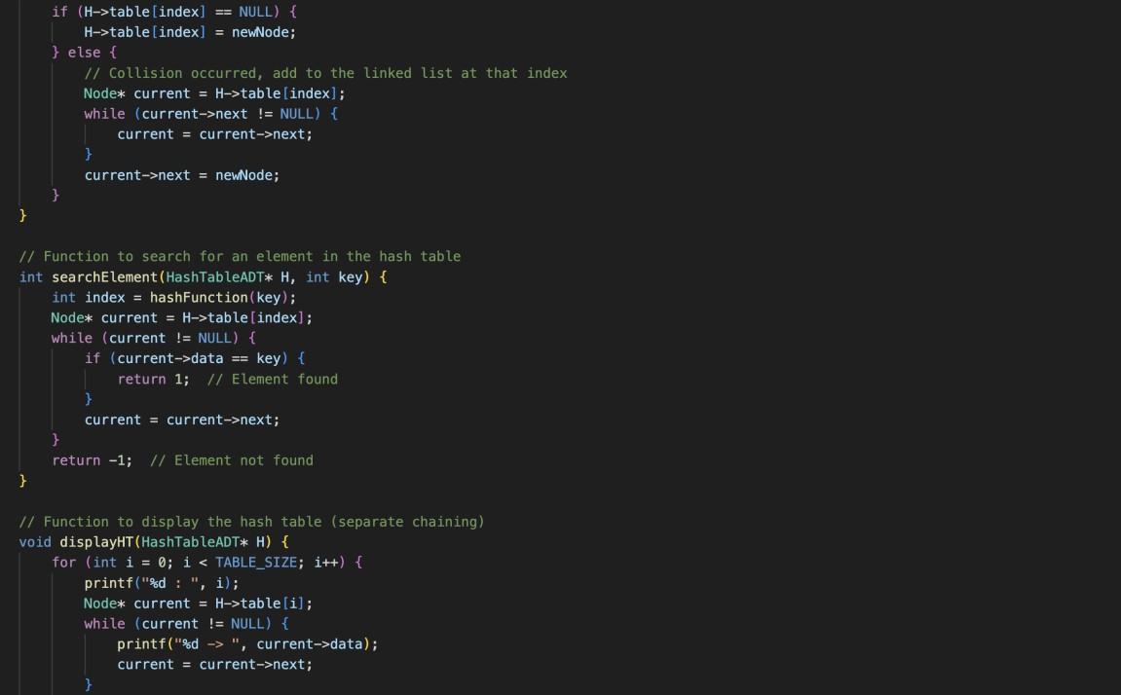

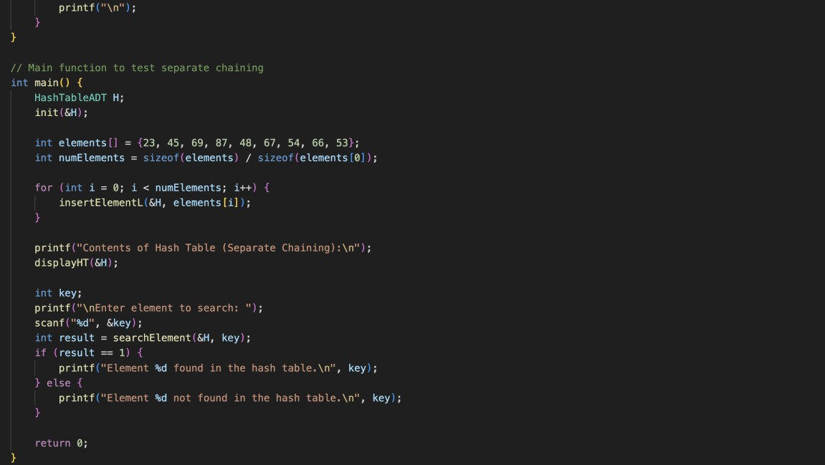

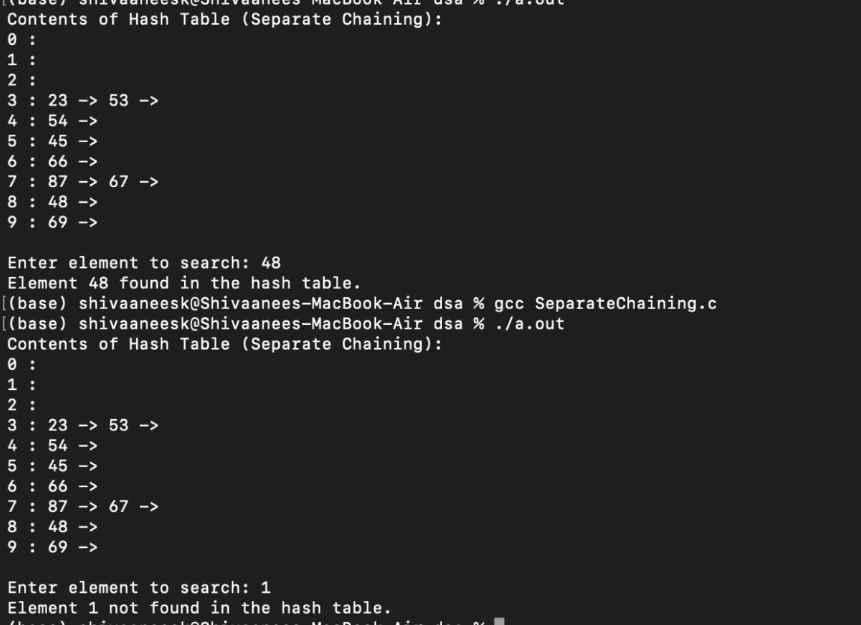

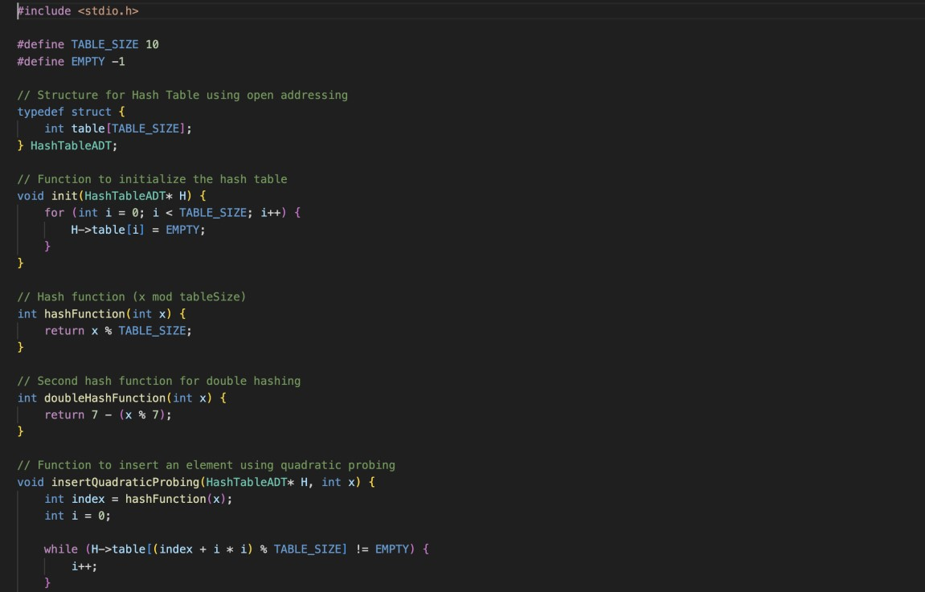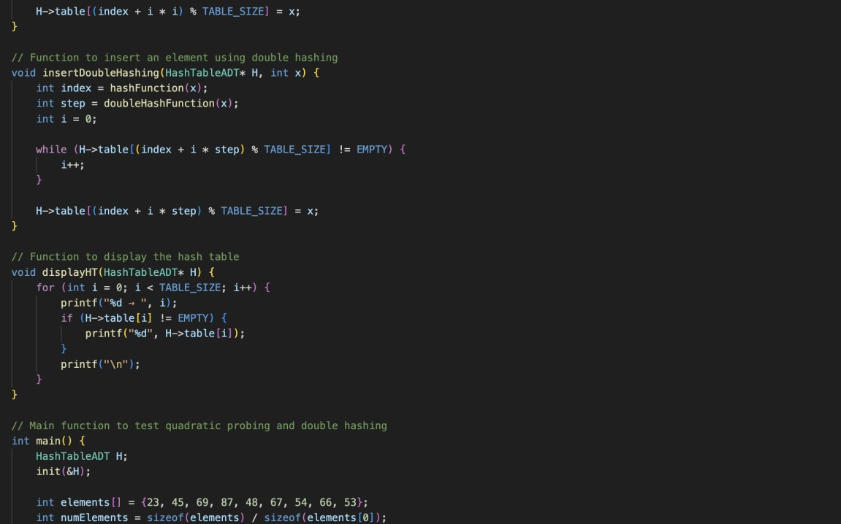

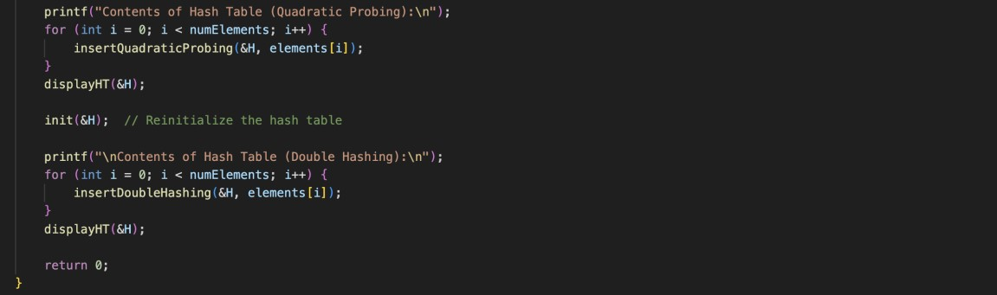

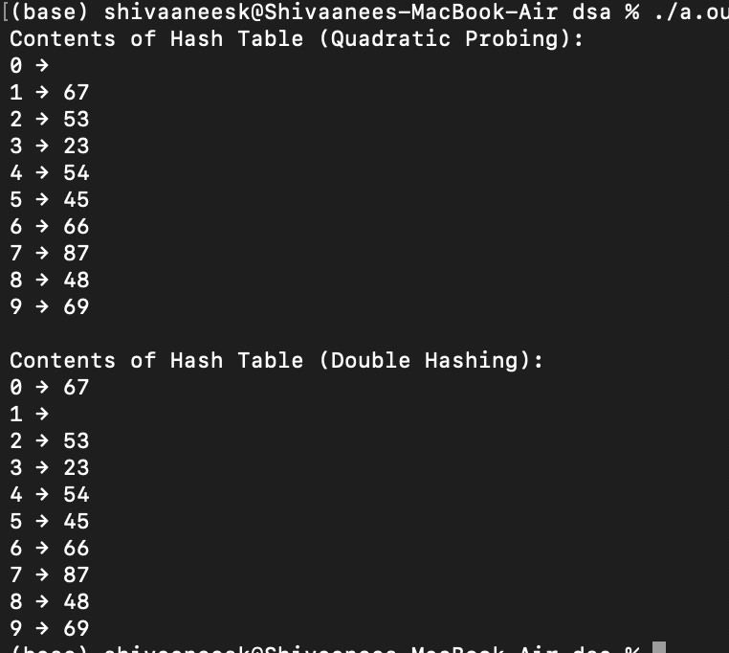

Technical Outcomes:

|  |  |  |
| --- | --- | --- |
| Design | 3 |  |
| Understanding DS | 3 |  |
| Usage of DS | 2 | Needs improvement |
| Debugging | 3 |  |

Best Practices:

|  |  |  |
| --- | --- | --- |
| Design before coding | 3 |  |
| Usage of algo | 3 |  |
| Multifile | 1 | Needs improvement |
| versioning | 3 |  |

**UCS 2312 Data Structures Lab**

**Assignment 12: Implementation of Searching and Sorting algorithms**

The numberADT contains the size of integer array and an array of integers. [CO2, K3]

* void init(numbertADT *N) – To initialize the size of the array
* void insertElements (numberADT *N, int x[10])– To copy the elements from x to

the array in numberADT

* void insSort(numberADT *N) – Sorting of elements in the array using selection sort
* void shellSort(numberADT *N) – Sorting of elements in the array using shell sort
* void display(numberADT *N) – Display the elements in the array

Additional Routines

Write a routine in ADT to find the element that appears once in sorted array with O(log n) time complexity.

Write a routine in ADT to count the number of 1’s in sorted array with O(log n) time complexity

In your notebook, design atleast 3 test cases to realize best/worst/average cases. For each test case, trace the additional routines and write the state of the array in each iteration. Verify your expected output with the actual output of your function.

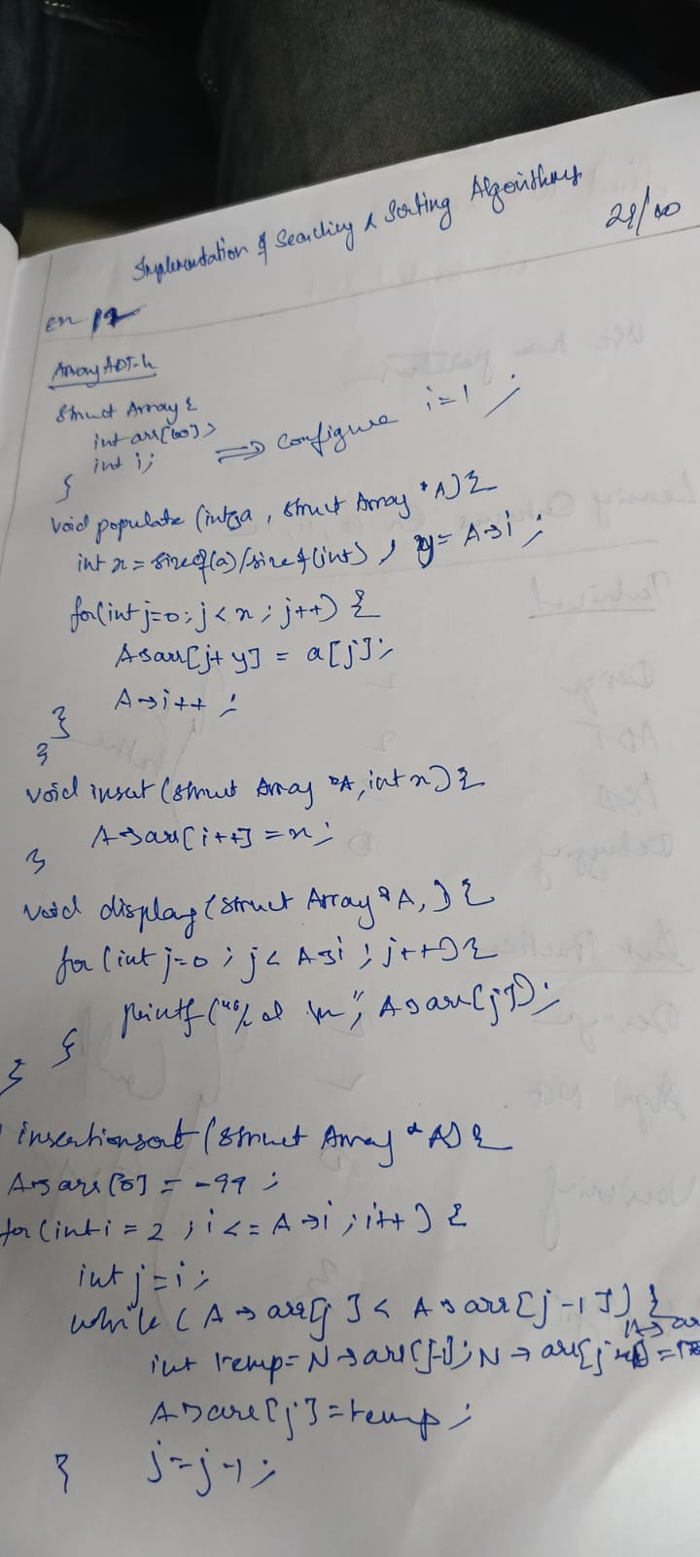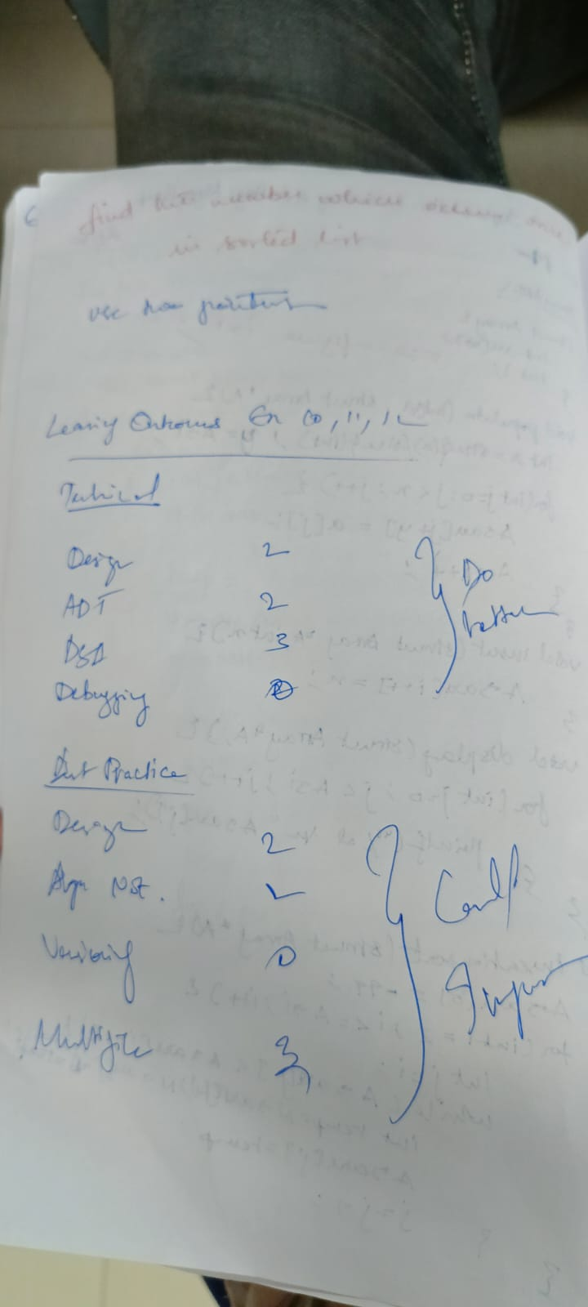

Technical Outcomes:

|  |  |  |
| --- | --- | --- |
| Design | 3 |  |
| Understanding DS | 3 |  |
| Usage of DS | 2 | Needs improvement |
| Debugging | 3 |  |

Best Practices:

|  |  |  |
| --- | --- | --- |
| Design before coding | 3 |  |
| Usage of algo | 3 |  |
| Multifile | 1 | Needs improvement |
| versioning | 3 |  |